November 8, 2024



Wildfire Prevention and Fighting Dashboard Design

Human-Computer-Interaction

Helena Silva  
up200803677@edu.fc.up.pt

Rui Costa  
up202108271@edu.fc.up.pt

Sérgio Cardoso  
up202107918@edu.fc.up.pt

Tomás Fontes  
up202107382@edu.fc.up.pt

Contents

Index of Figures 2

Index of Tables 3

Introduction 4

Section 1 5

1.1 Problem Description 5

1.2 Biggest Challenges 6

1.3 Identification of Stakeholders 6

1.4 Personas as Potential Users 7

Section 2 8

2.1 Outline of Implement Features 8

2.2 Metrics Used for Evaluation 20

2.3 Evaluation and Results 20

2.4 Iteration Process 28

2.5 How to Interact with the Graphical Interfaces Created 30

Conclusão 32

Bibliographical References 33

Appendices i

A – Information about fire vehicles and procedures during wildfires i

# Index of Figures

Figure 1 - ICNF rural fire indicators. 4

Figure 2 - Maps of Aveiro District 5

Figure 3 - Persona 1 7

Figure 4 - Persona 2 7

Figure 5 - Situation Panel - Sketch 1 9

Figure 6 - Situation Panel - Sketch 2 Figure 7 - Situation Panel - Sketch 3 9

Figure 8 - Situation Panel - Sketch 4 Figure 9 - Situation Panel - Sketch 5 10

Figure 10 - Situation Panel - Sketch 6 Figure 11 - Situation Panel - Sketch 7 10

Figure 12 - Situation Panel - Sketch 8 Figure 13 - Situation Panel - Sketch 9 11

Figure 14 - Multiple Sensors Sketch 1 Figure 15 - Multiple Sensors Sketch 2 11

Figure 16 - Multiple Sensors Sketch 3 Figure 17 - Multiple Sensors Sketch 4 12

Figure 18 - Multiple Sensors Sketch 5 Figure 19 - Multiple Sensors Sketch 6 12

Figure 20 - Camara Panel Sketch 1 Figure 21 - Camara Panel Sketch 2 13

Figure 22 - Camara Panel Sketch 3 Figure 23 - Camara Panel Sketch 4 13

Figure 24 - Camara Panel Sketch 5 Figure 25 - Camara Panel Sketch 6 14

Figure 26 - - Camara Panel Sketch 7 Figure 27 - Camara Panel Sketch 8 14

Figure 28 - Camara Panel Sketch 9 15

Figure 29 - Log Panel Sketch 1 Figure 30 - Log Panel Sketch 2 15

Figure 31 - Log Panel Sketch 3 16

Figure 32 - Log Panel Sketch 4 Figure 33 - Log Panel Sketch 5 16

Figure 34 - Resources Panel Sketch 1 Figure 35 - Resources Panel Sketch 2 17

Figure 36 - Resources Panel Sketch 3 Figure 37 - Resources Panel Sketch 4 17

Figure 38 - Resources Panel Sketch 5 18

Figure 39 - Resources Panel Sketch 6 Figure 40 - Resources Panel Sketch 7 18

Figure 41 - Resources Panel Sketch 8 with auxiliary screen 19

Figure 42 - Situation Panel Sketch 10 Figure 43 - Situation Panel Sketch 11 28

Figure 44 - Multiple sensors Sketch 7 Figure 45 - Multiple Sensors Sketch 8 28

Figure 46 - Log Panel Sketch 6 Figure 47 - Camara Panel Sketch 10 29

Figure 48 - Resources Panel Sketch 9 29

Figure 49 - The preliminary version of the dashboard at the stage of development 30

# Index of Tables

Table 1 - Situation Panel evaluation of the functionality parameter 20

Table 2 - Situation Panel evaluation of the intuitiveness parameter 21

Table 3 - Situation Panel evaluation of the organization parameter 21

Table 4 - Situation Panel evaluation of the attractiveness parameter 21

Table 5 - Situation Panel final scor 21

Table 6 - Multiple sensors evaluation of the functionality parameter 22

Table 7 - Multiple Sensors evaluation of the intuitiveness parameter 22

Table 8 - Multiple Sensors organization of the parameter 22

Table 9 - Multiple Sensors evaluation of the attractiveness parameter 23

Table 10 - Multiple Sensors sinal score 23

Table 11 - Camaras Panel evaluation of the functionality parameter 23

Table 12 - Camaras Panel evaluation of the intuitiveness parameter 24

Table 13 - Camaras Panel evaluation of the organization parameter 24

Table 14 - Camaras Panel evaluation of the attractiveness parameter 24

Table 15 - Camaras Panel final score 24

Table 16- Log Panel evaluation of the functionality parameter 25

Table 17- Log Panel evaluation of the intuitiveness parameter 25

Table 18- Log Panel evaluation of the organization parameter 25

Table 19 - Log Panel evaluation of the attractiveness parameter 26

Table 20 - Log Panel final score 26

Table 21- Resources Panel evaluation of the functionality parameter 26

Table 22 - Resources Panel evaluation of the intuitiveness parameter 27

Table 23 - Resources Panel evaluation of the organization parameter 27

Table 24 - Resources Panel evaluation of the attractiveness parameter 27

Table 25 - Resources Panel final score 27

Table 27 - Forest firefighting vehicles i

# Introduction

As time goes by, we come to the conclusion that wildfires are some of the most fierce and dangerous threats to human and wildlife safety.

As reported by the Institute for Nature Conservation and Forests (ICNF), the number of fire incidents in rural areas has exceeded 6,000 since the beginning of this year, with a total area of over 137,000 hectares affected by fire.

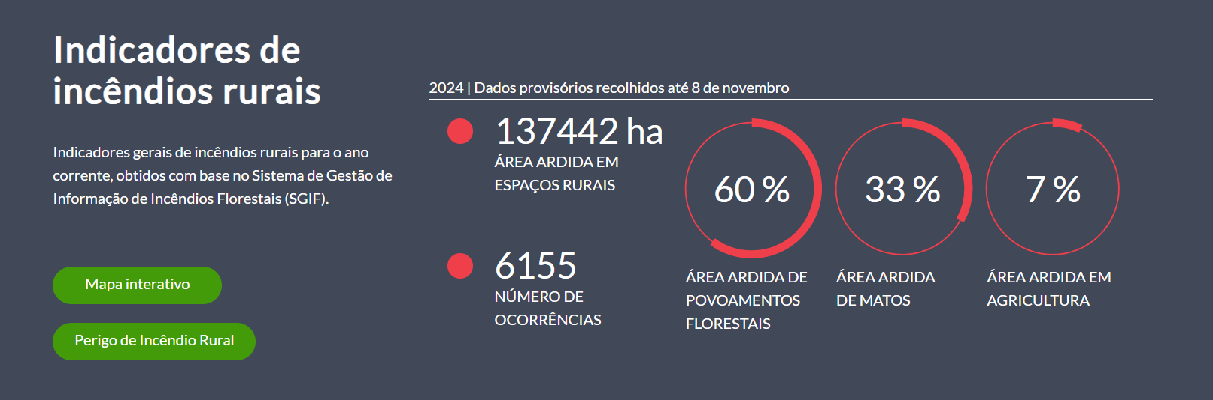

Figure 1 - ICNF rural fire indicators.

One of the ways to prevent wildfires is by using technological tools that can detect and combat them more effectively.

The project is comprised of several stages, which have been classified into four sections:

* Section 1: from the problem description to the definition of stakeholders;
* Section 2: from the designed sketches to the iteration process;
* Section 3: from the description of the sketches in low fidelity to a description of the constituent parts of the requested system for this project;
* Section 4: from aspects of human interaction with the system to the overall improvements made.

This report will focus on the initial two sections, which have been the primary focus of the project thus far.

# **Section 1**

## 1.1 Problem Description

For this work, we were given the task to create a dashboard that could simulate a realtime, real-world system for wildfire prevention. In order to fulfil the above-mentioned objective, we were required to select one of two districts, namely Aveiro or Viseu. Our task was to analyse both districts, with a particular focus on the forest area in each. This area was considered crucial, since that it would be the location of the deployment of cameras and sensors, which would be used to collect data essential for preventing forest fires. To achieve that goal, Silvanet Wildfire Sensors and Mesh Gateways are necessary to survey and detect wildfires effectively.

In this particular instance, the decision was taken to select the Aveiro district. The district is situated in close proximity to our location, which constitutes one of the factors that led to our decision to select it. As illustrated in the district maps below, this district is characterised by a significant forest area. To be more precise, the total area of the Aveiro district is approximately 2808 km², with the forest area accounting for approximately 1400 km².

Furthermore, the district has 4,485 sensors and 446 gateways at the disposal of civil protection agencies.

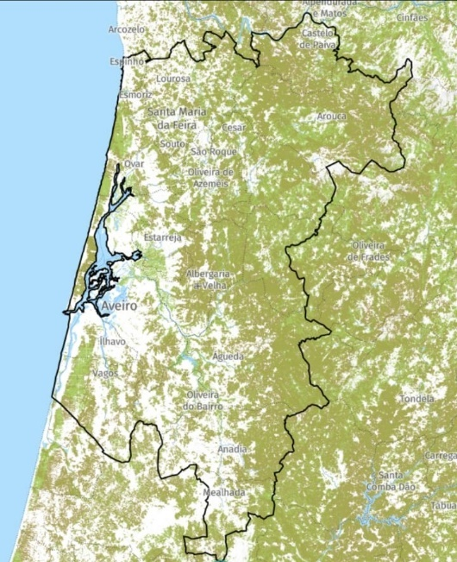 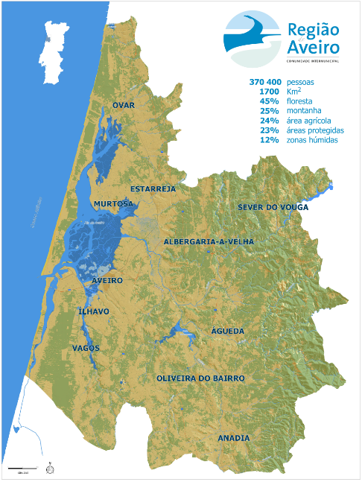

Figure 2 - Maps of Aveiro District

## 1.2 Biggest Challenges

One of the biggest challenges we faced was keeping a complex system, with multiple functionalities, simple and intuitive to use without the need for prior knowledge on this specialized tech, such as the sensors and gateways.

## 1.3 Identification of Stakeholders

In the context of this project, “stakeholders” can be defined as follows:

* Dryad (Sensor Manufacturer)
* Firefighters
* SIRESP - Portuguese National Emergency and Security Networks Operator
* Civil Protection
* City Council
* System Operators (from Civil Protection)

All these entities play a crucial role in the process of fire monitoring and firefighting. Civil Protection agencies and firefighters rely on this interface to facilitate effective emergency responses and ensure public safety. Sensor and camera manufacturers contribute valuable technology that is essential for accurate data capture, enabling timely and precise detection.

Local authorities have a vested interest in protecting their local areas and resources, and benefit from a tool that enhances their preparedness and risk management strategies.

Finally, system operators are integral to ensure smooth operations, maintenance, and real-time monitoring capabilities which, in turn, make it possible for all stakeholders to rely on accurate and up-to-date information.

## 1.4 Personas as Potential Users

In order to come up with some of the sketches shown in Chapter 3, we created two fictional personas, in this case, two fictional potential users of the system. In the end, we came up with the following:

**Persona 1:**

* 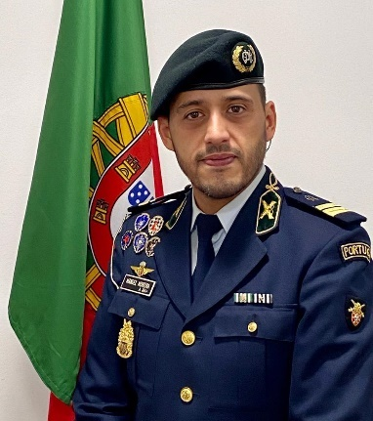Joaquim Soares (35 years old):

Figure 3 - Persona 1

* + Civil Protection agent;
  + Lives with his wife and kids in Aveiro;
  + Joined GNR and received police training at the age of 20;
  + Worked as GNR in Aveiro’s district during the wildfires of Summer of 2024. After this catastrophic experience, he volunteered to become a Civil Protection Agent in this new program to prevent and fight forest wildfires.

**Persona 2:**

* João Rodrigues (24 years old):
  + Has a degree in Management of Safety, Emergency, and Civil Protection;

Figure 4 - Persona 2

* + Lives with his parents and sister in Aveiro
  + Currently undertaking a post-graduation degree in Civil Protection, through online classes
  + Works as an operations assistant for Civil Protection.
  + Has ambitions to climb the ranks in ANEPC by gathering experience in various Fields

# **Section 2**

## 2.1 Outline of Implement Features

Prior to proceeding with the sketch, it was necessary to define which panels would be utilized in the application. In accordance with the recommendations provided by the professor, the decision was made to create five panels. The following panels were created: Situation Panel, Log Panel, Cameras Panel, Resources Panel and Auxiliary Screens.

For each panel, an analysis was conducted to identify the most pertinent characteristics to be considered. In regard to the Situation Panel, it was determined that an essential preliminary step would be the utilization of a map of the district, in conjunction with the delineation of the locations of the fires and their respective conditions.

When considering the Log Panel, it was determined in advance that the ability to select, aggregate and filter data, such as contract or expand information, would be beneficial in facilitating the interpretation of the available information.

In relation to the Camera Panel, it was established that the panel would contain six cameras, and that it would be advantageous to have the ability to manipulate these, for example, by zooming in, panning left and right, and moving up and down. Furthermore, it was hypothesised that it would be advantageous to have the option of capturing an image of the visualisation currently being displayed by the camera.

When considering the Resources Panel, it is evident that the aspect of localization is of significant importance, as is the communication between the civil protection operator and the fire-fighting resources that would be in operation, including air, ground and human resources. These resources may include fire crews, tankers, reconnaissance vehicles, heavy or light bomber helicopters and seaplanes, among other.

It is also essential that the Auxiliary Screens are capable of adapting to the specific functionalities required by each of the preceding panels. To illustrate, the ability to select, enlarge a camera or map, handle the panels or display pertinent information in greater detail would be beneficial.

In consideration of the preceding factors, the initial sketches were formulated, which are presented below in a systematic arrangement by panels.

* Situation Panel:
  + Single:

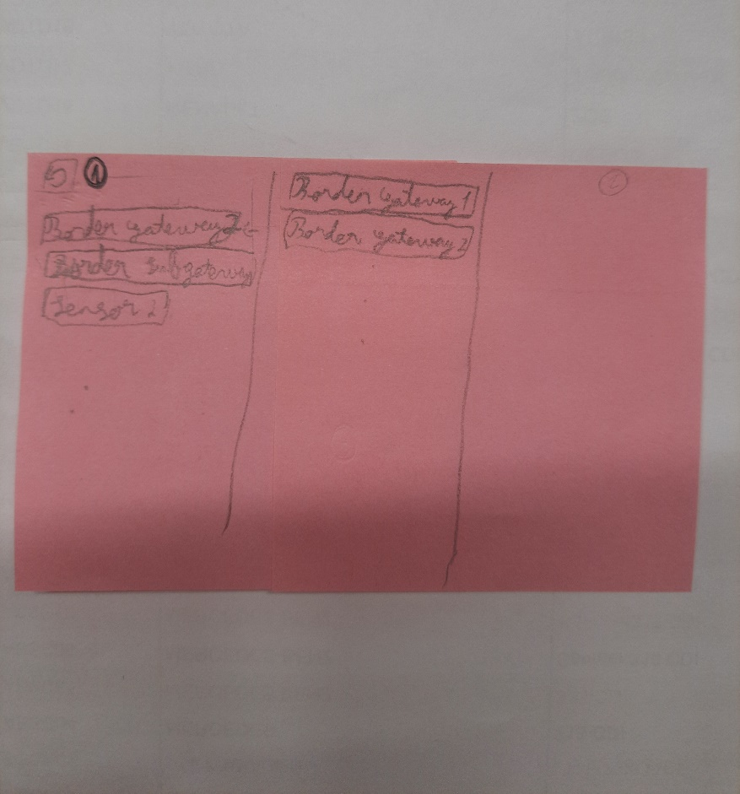

Figure 5 - Situation Panel - Sketch 1

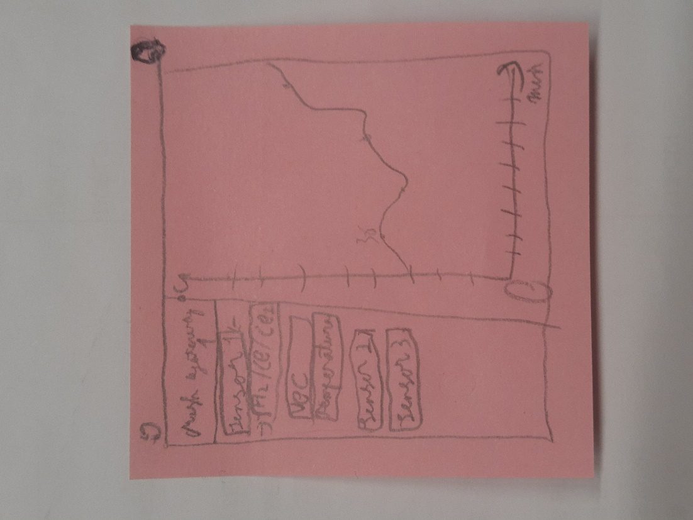 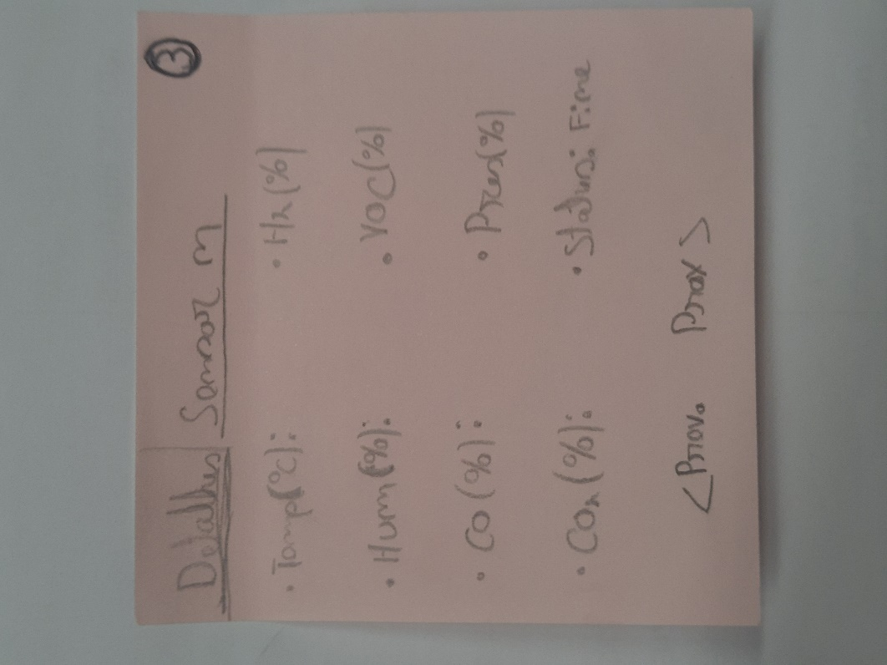

Figure 6 - Situation Panel - Sketch 2 Figure 7 - Situation Panel - Sketch 3

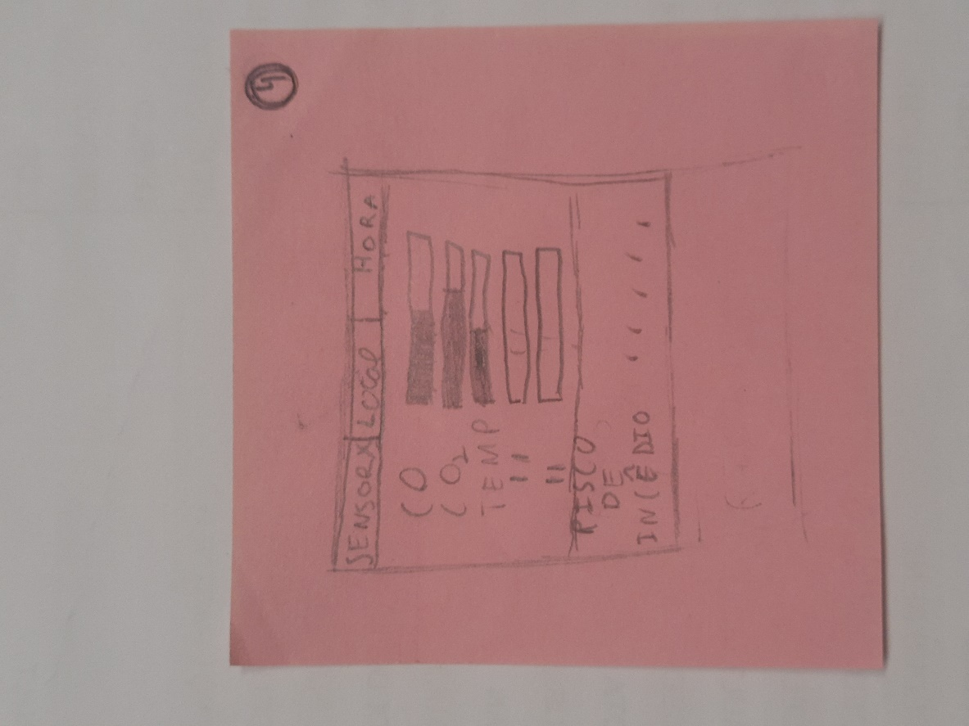 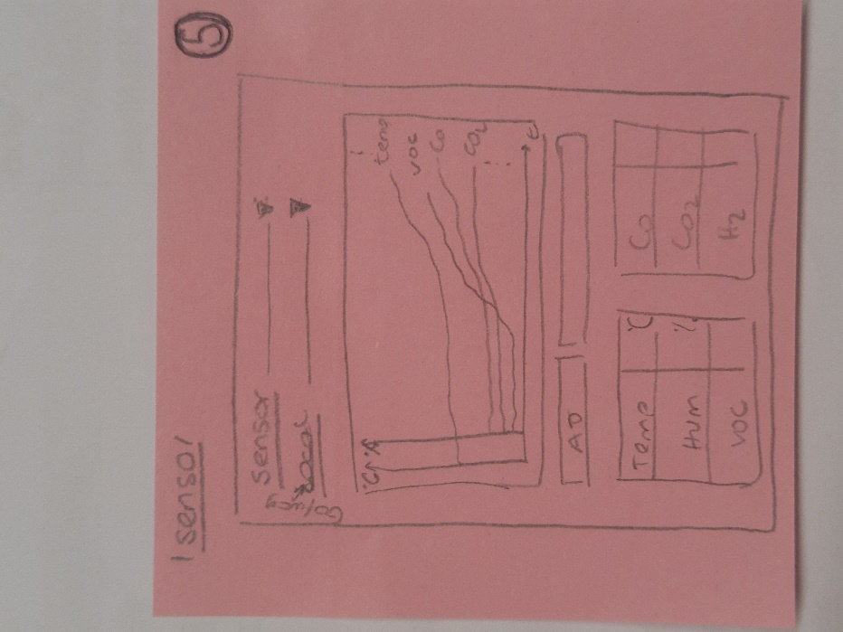

Figure 8 - Situation Panel - Sketch 4 Figure 9 - Situation Panel - Sketch 5

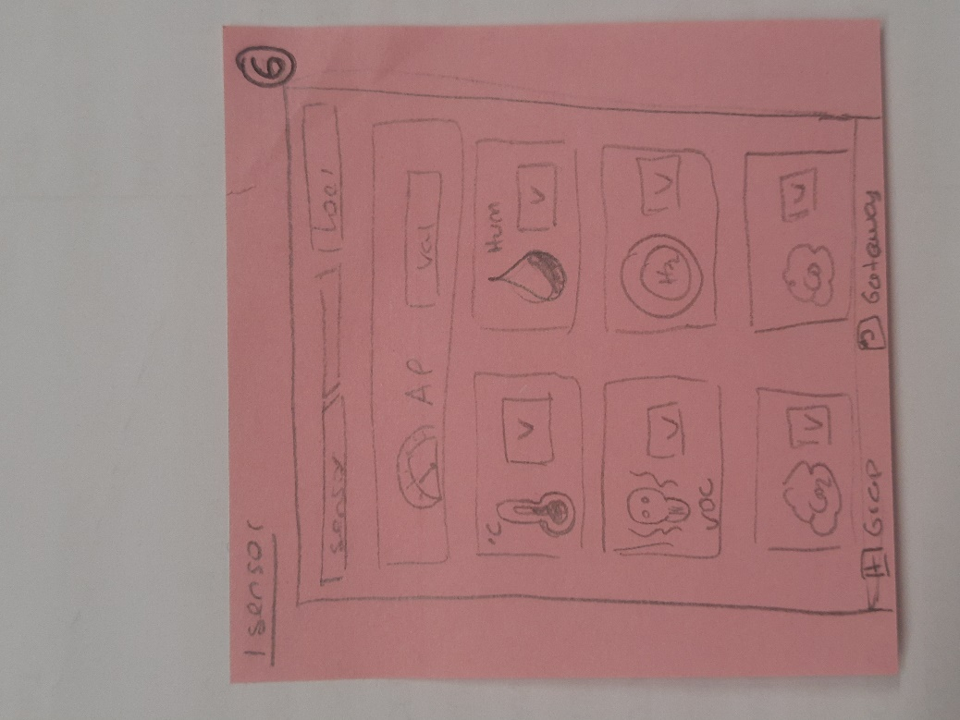 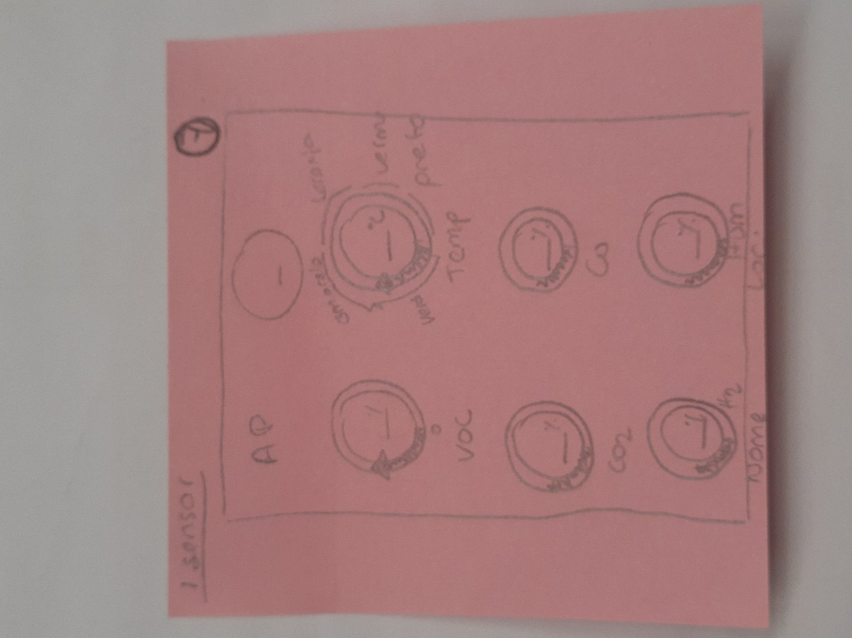

Figure 10 - Situation Panel - Sketch 6 Figure 11 - Situation Panel - Sketch 7

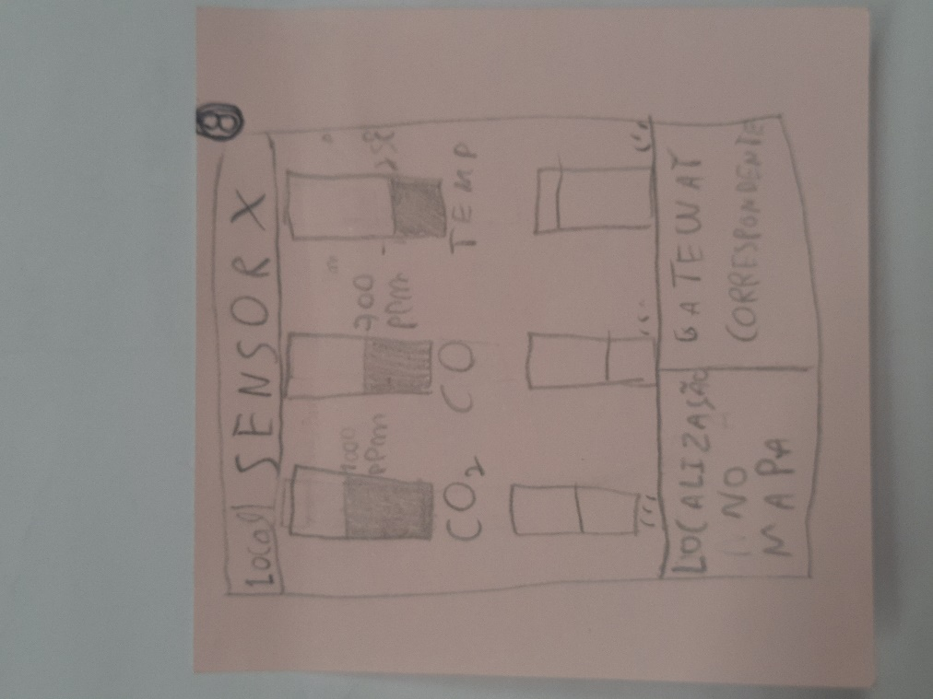 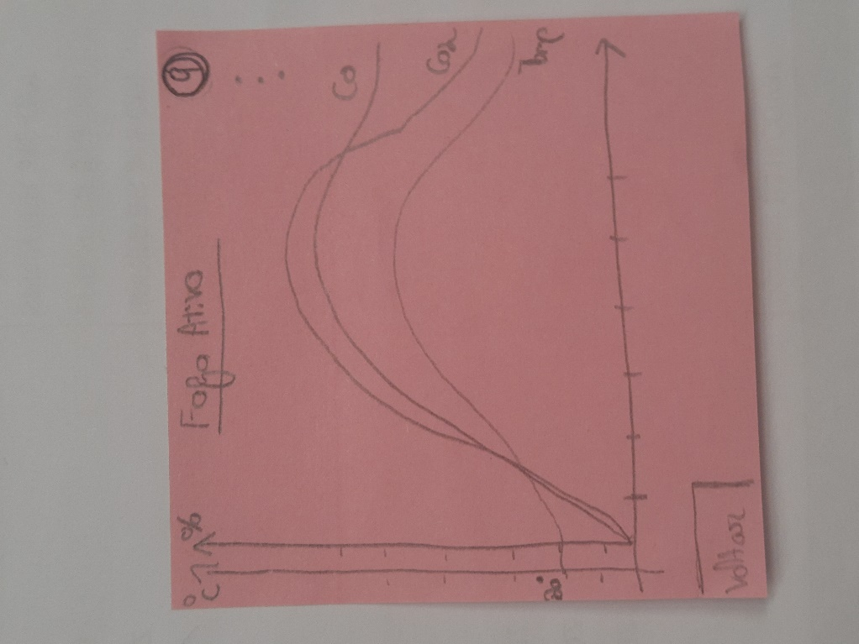

Figure 12 - Situation Panel - Sketch 8 Figure 13 - Situation Panel - Sketch 9

* + Multiple Sensors:

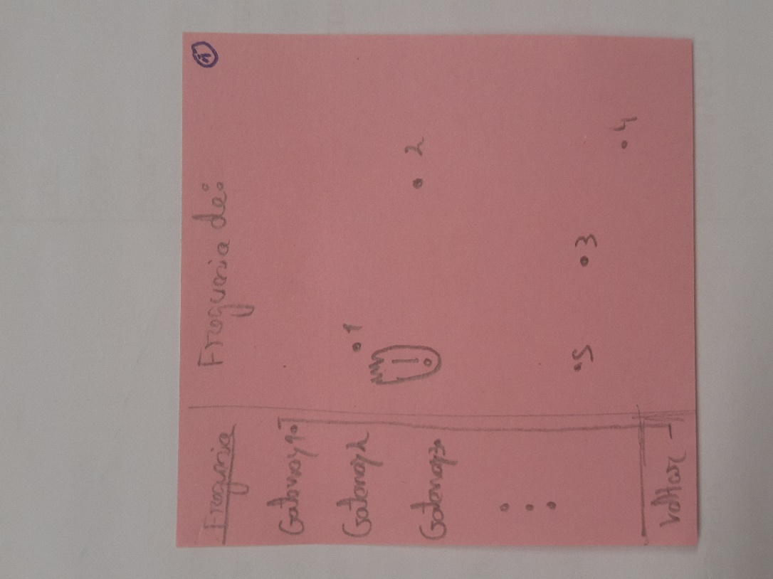 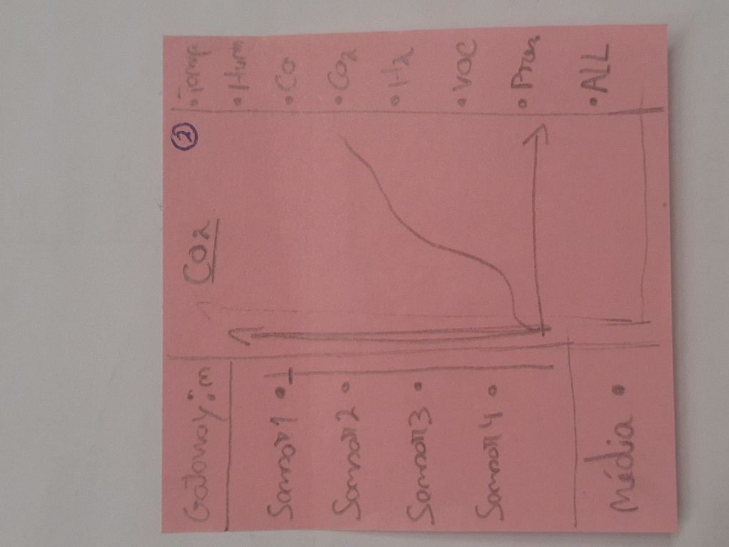

Figure 14 - Multiple Sensors Sketch 1 Figure 15 - Multiple Sensors Sketch 2

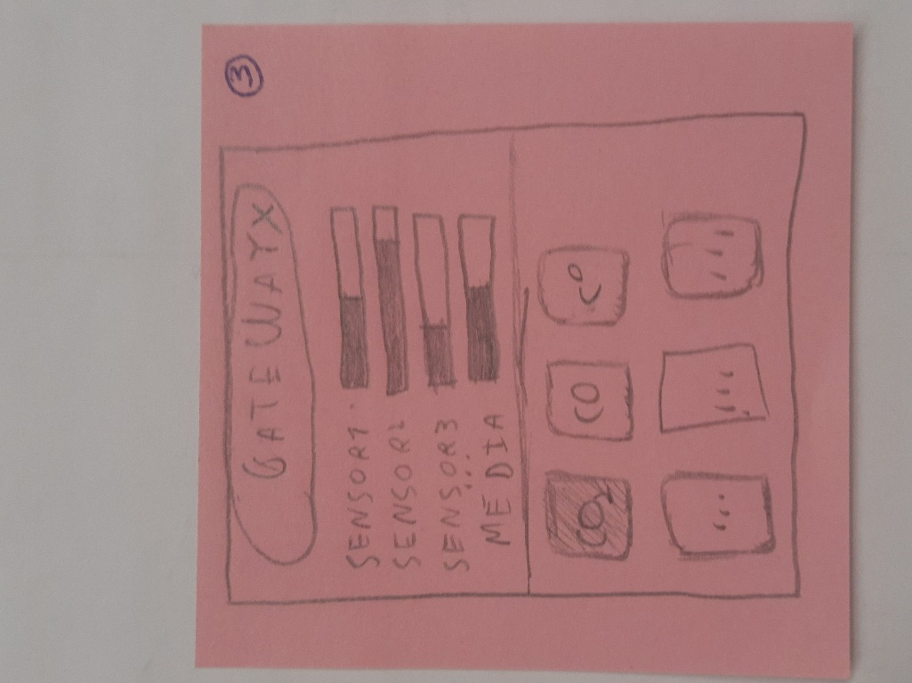 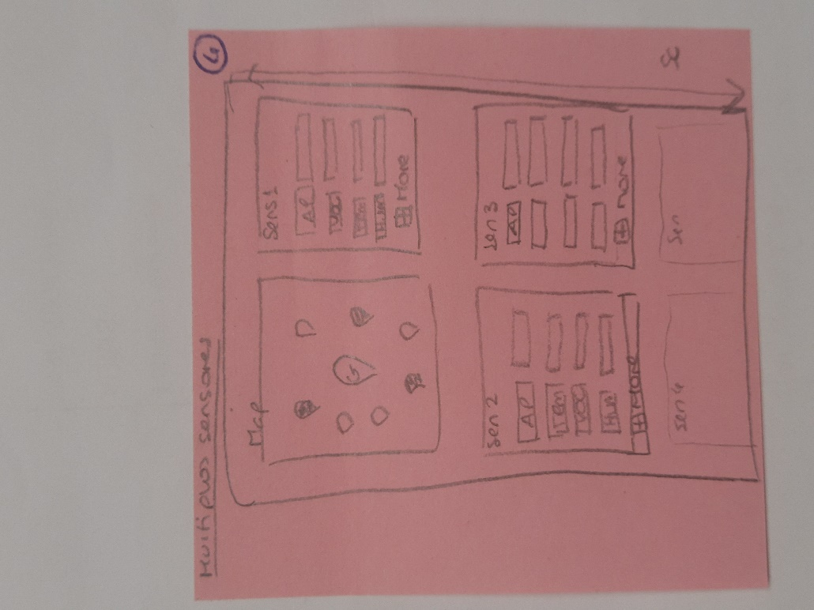

Figure 16 - Multiple Sensors Sketch 3 Figure 17 - Multiple Sensors Sketch 4

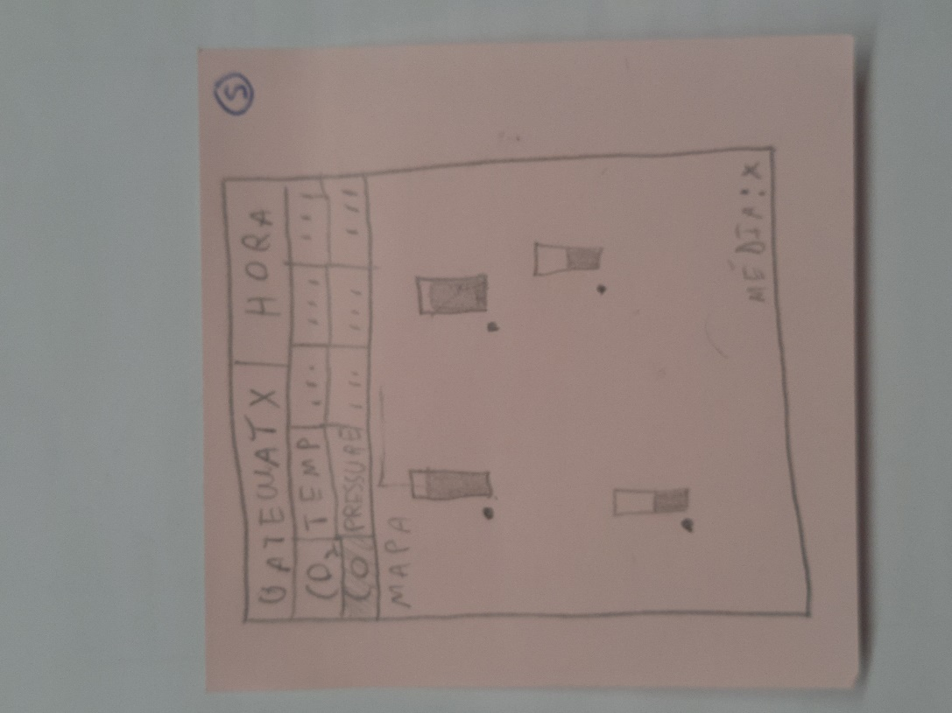 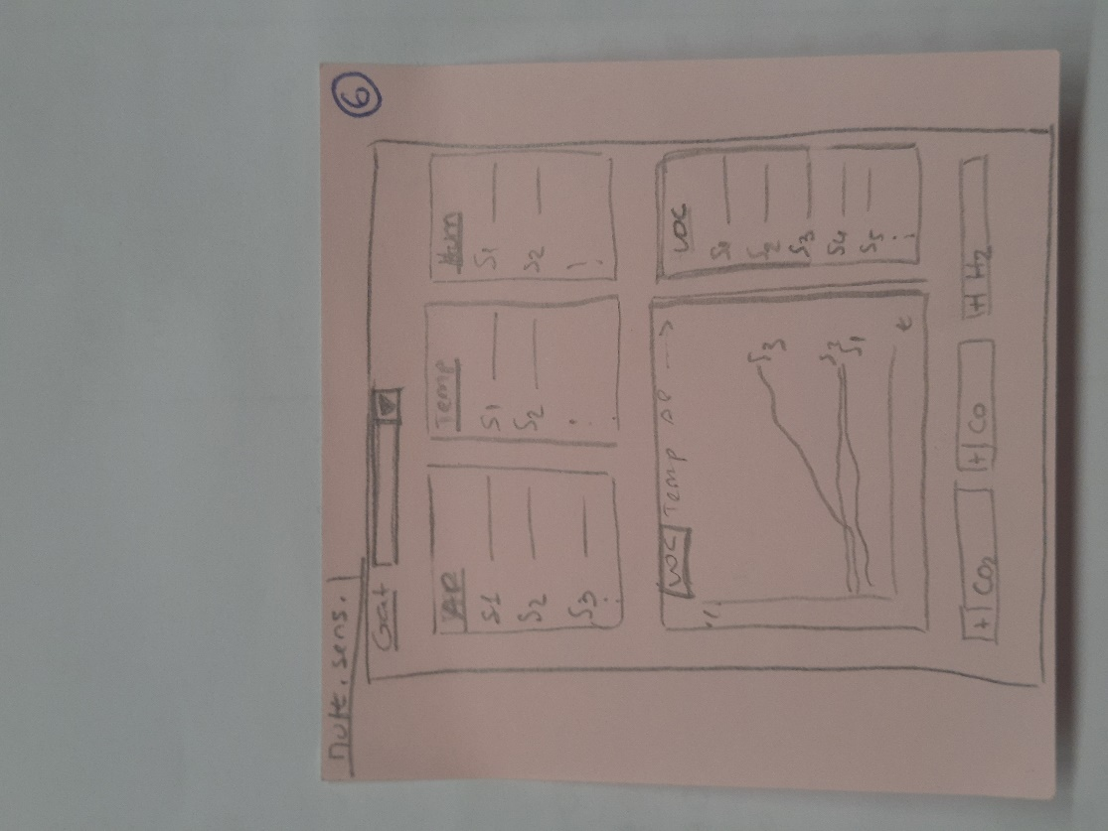

Figure 18 - Multiple Sensors Sketch 5 Figure 19 - Multiple Sensors Sketch 6

* Camaras Panel:

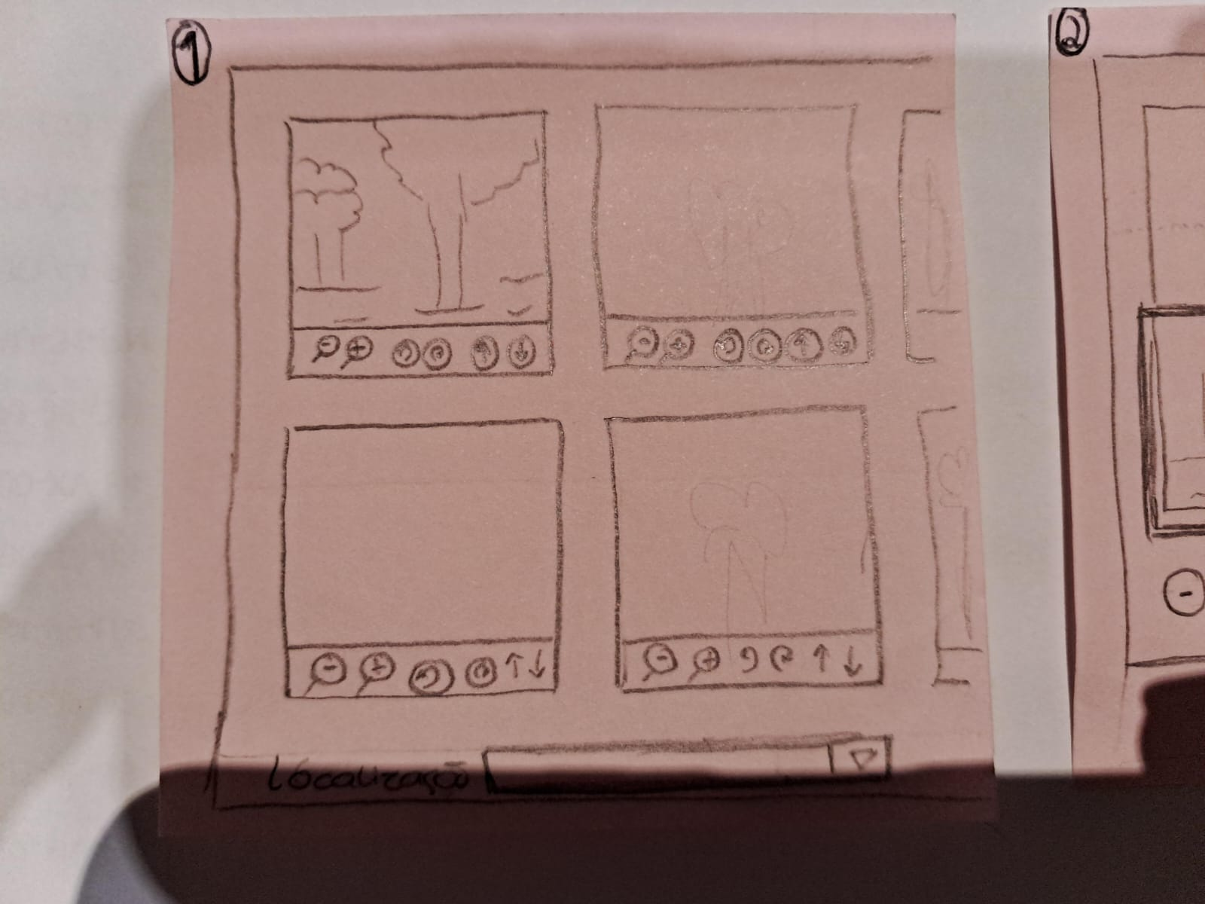 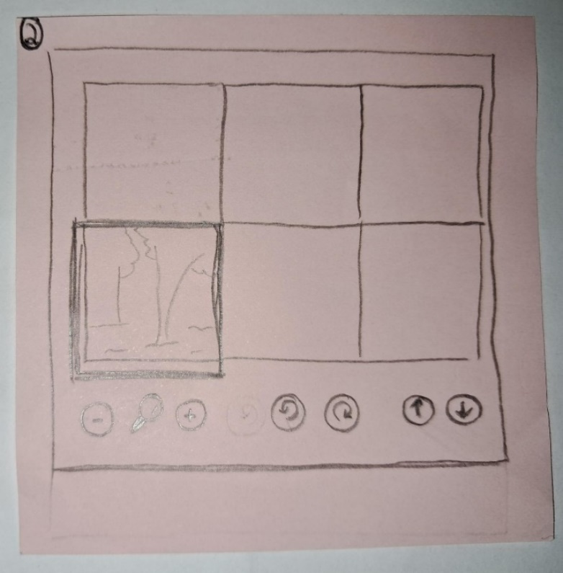

Figure 20 - Camara Panel Sketch 1 Figure 21 - Camara Panel Sketch 2

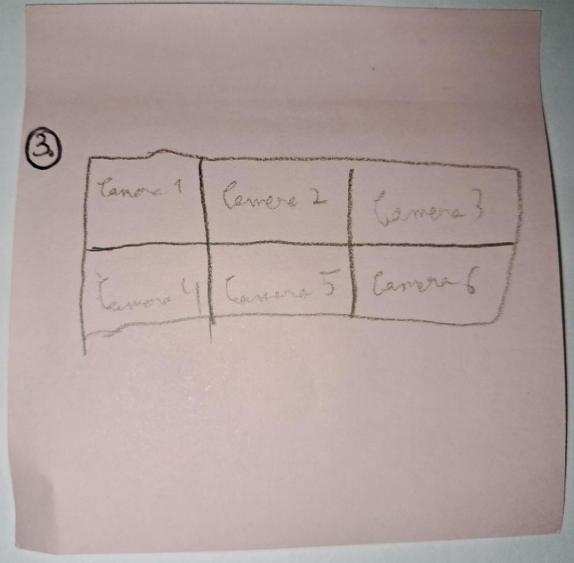 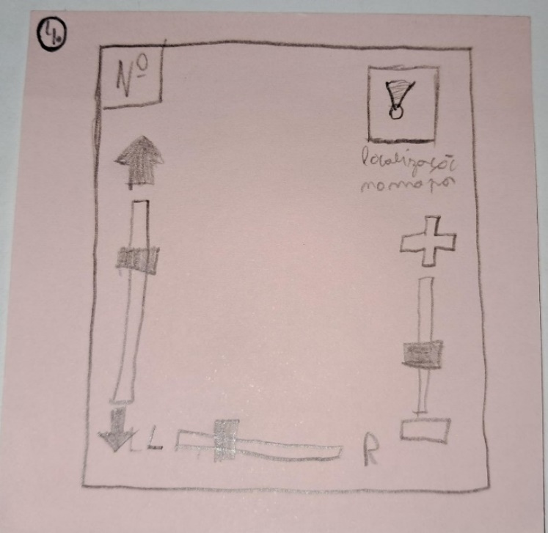

Figure 22 - Camara Panel Sketch 3 Figure 23 - Camara Panel Sketch 4

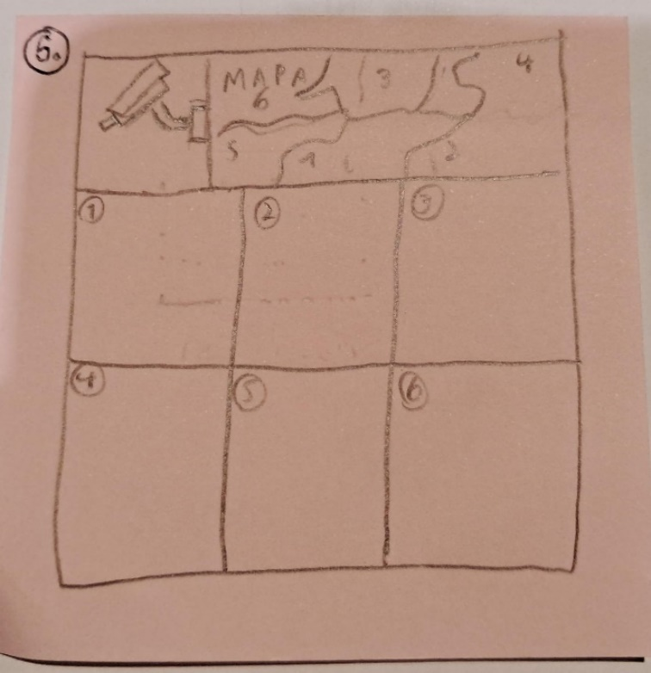 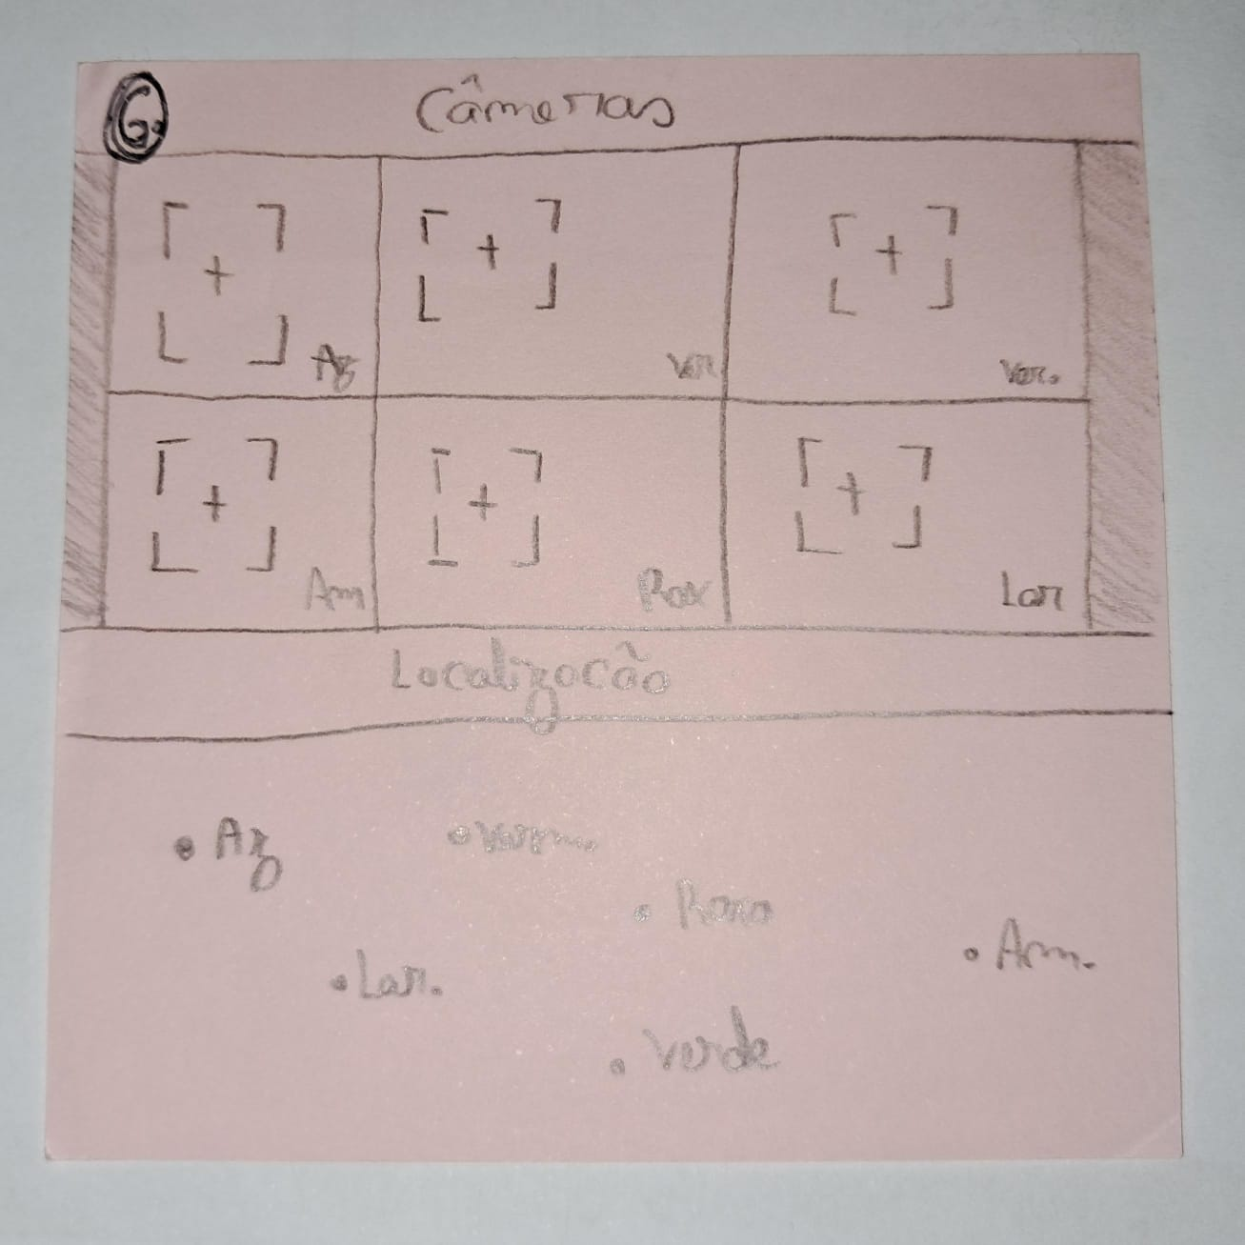

Figure 24 - Camara Panel Sketch 5 Figure 25 - Camara Panel Sketch 6

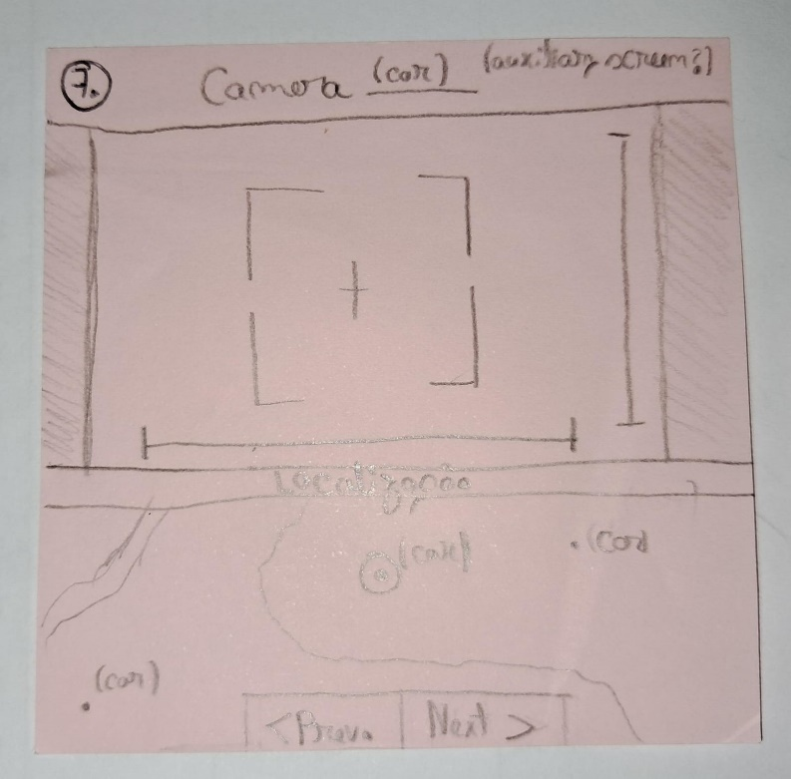 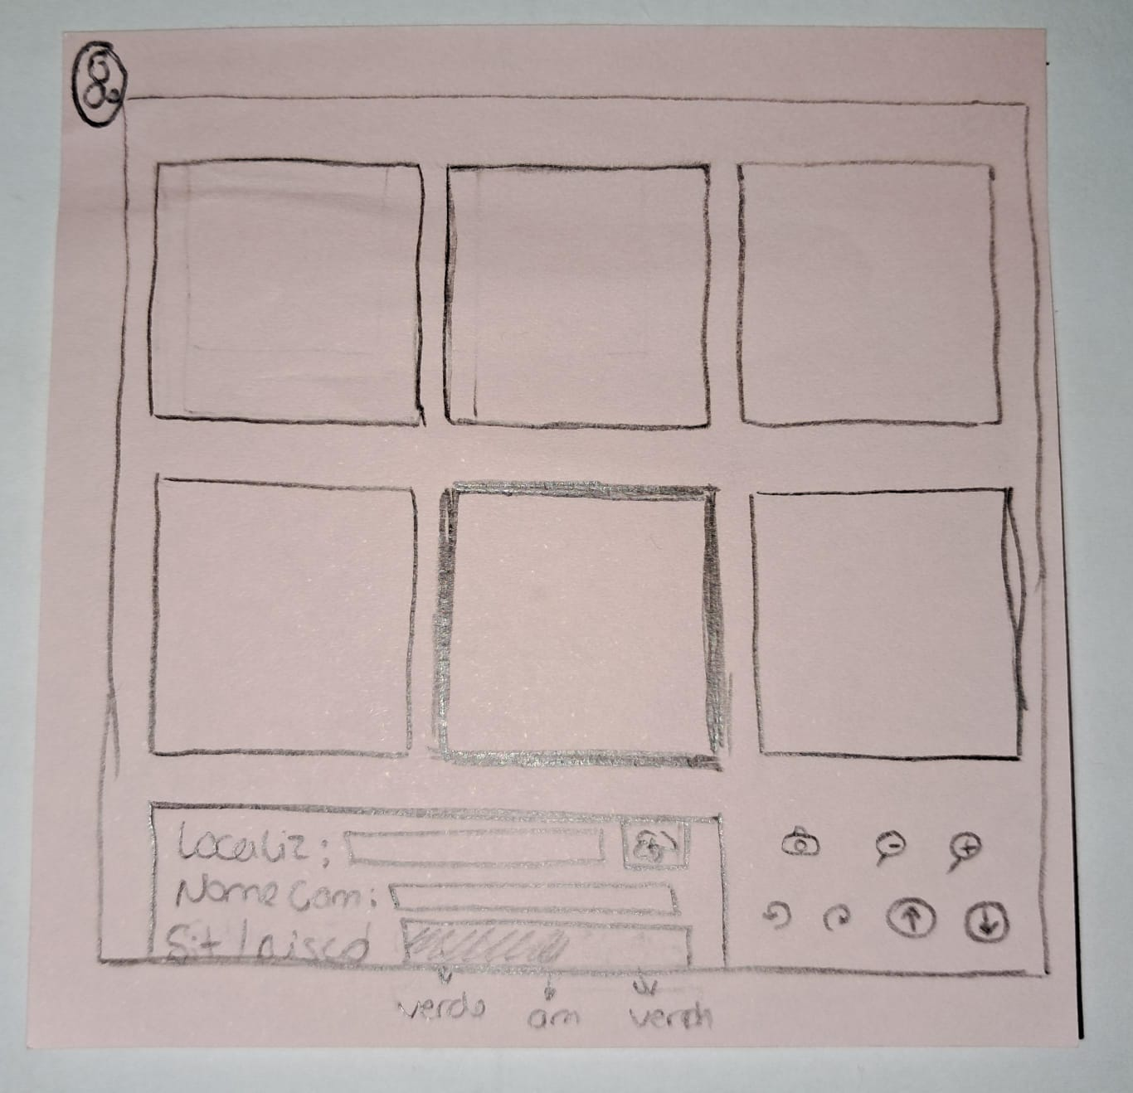

Figure 26 - - Camara Panel Sketch 7 Figure 27 - Camara Panel Sketch 8

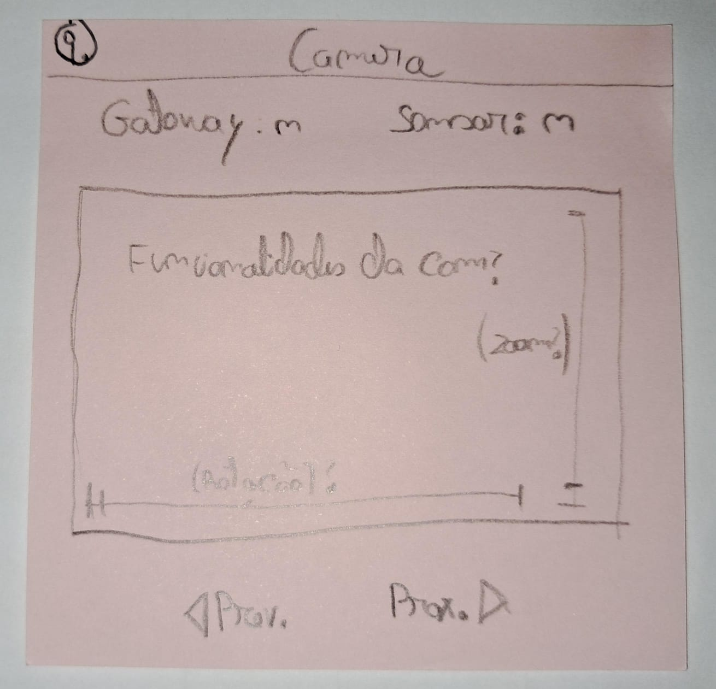

Figure 28 - Camara Panel Sketch 9

* Log Panel:

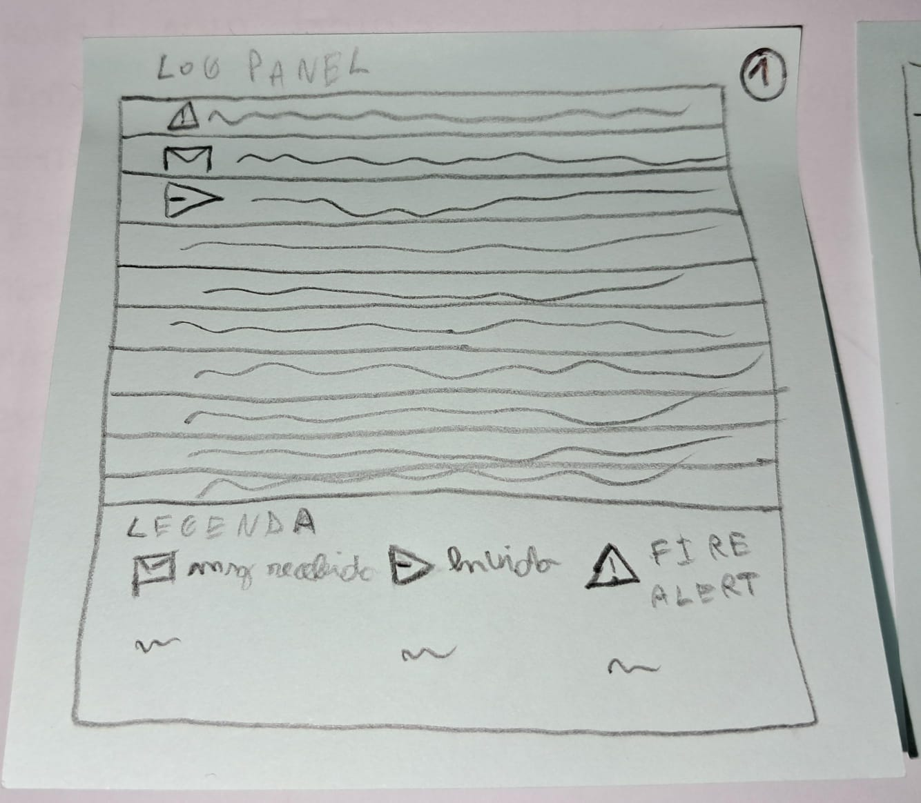 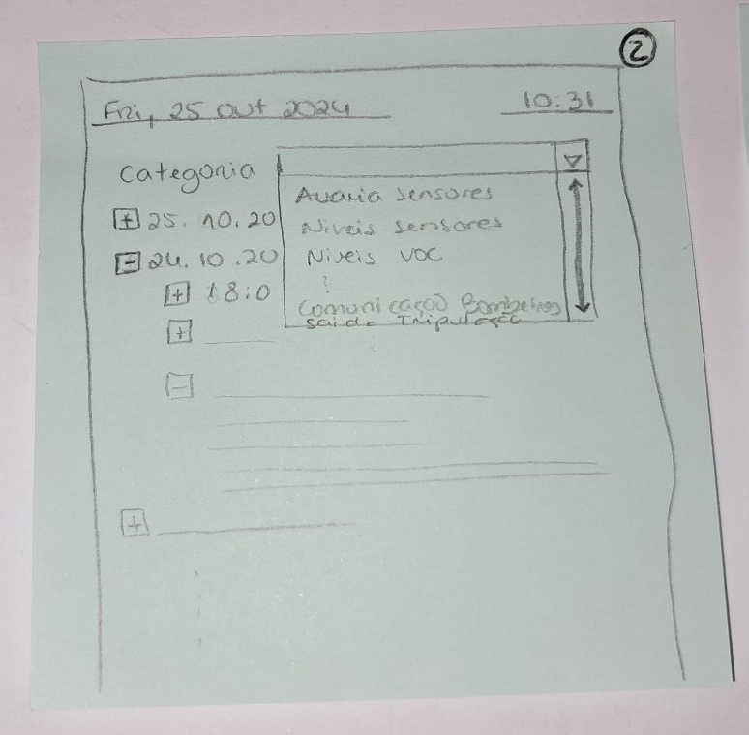

Figure 29 - Log Panel Sketch 1 Figure 30 - Log Panel Sketch 2

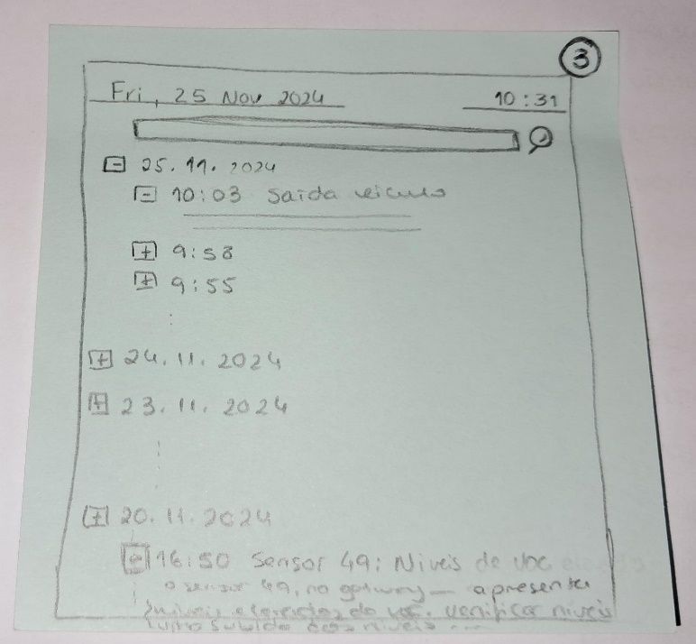

Figure 31 - Log Panel Sketch 3

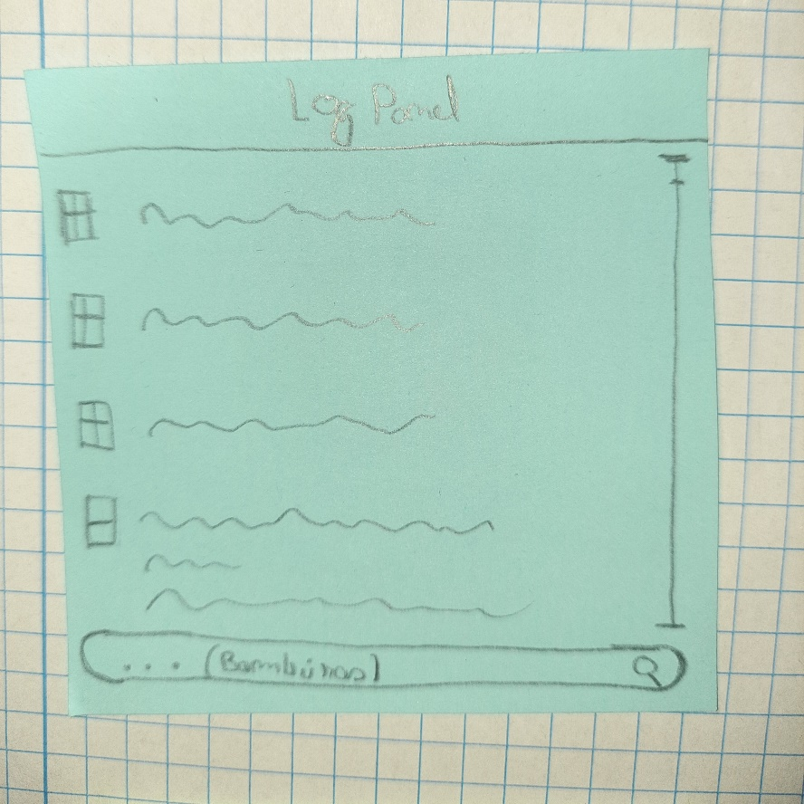 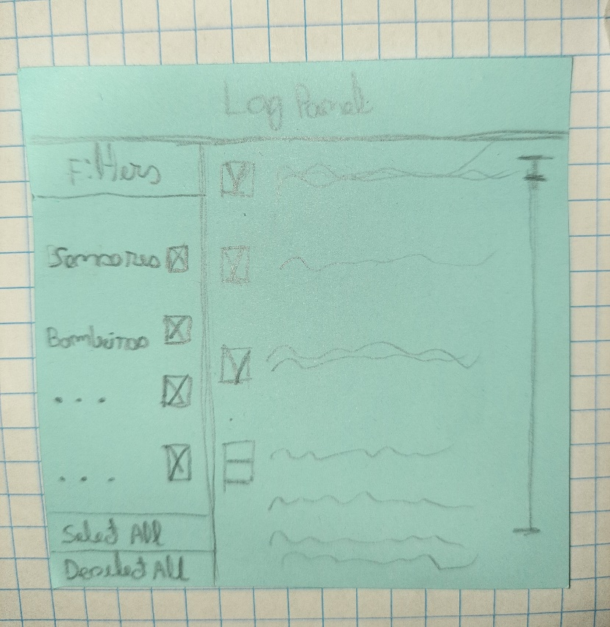

Figure 32 - Log Panel Sketch 4 Figure 33 - Log Panel Sketch 5

* Resources Panel:

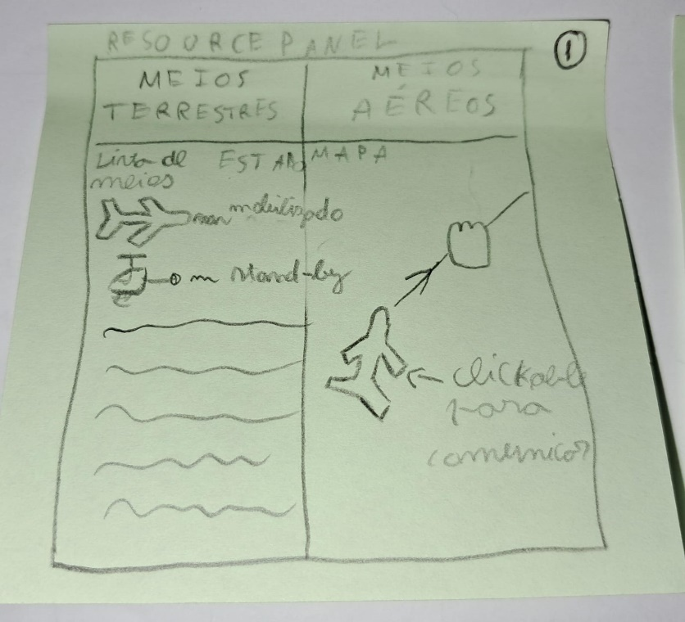 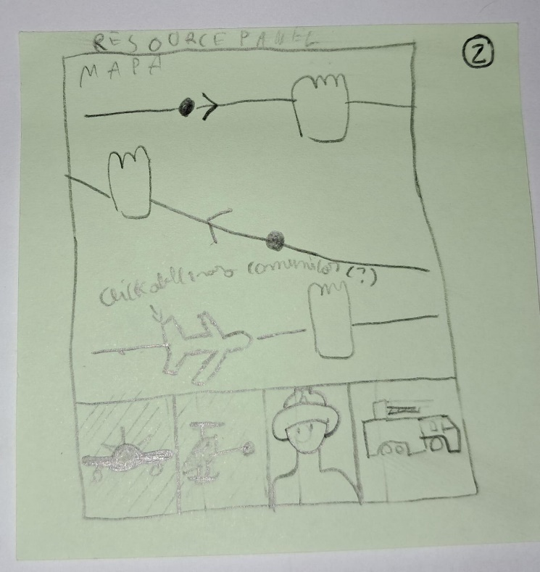

Figure 34 - Resources Panel Sketch 1 Figure 35 - Resources Panel Sketch 2

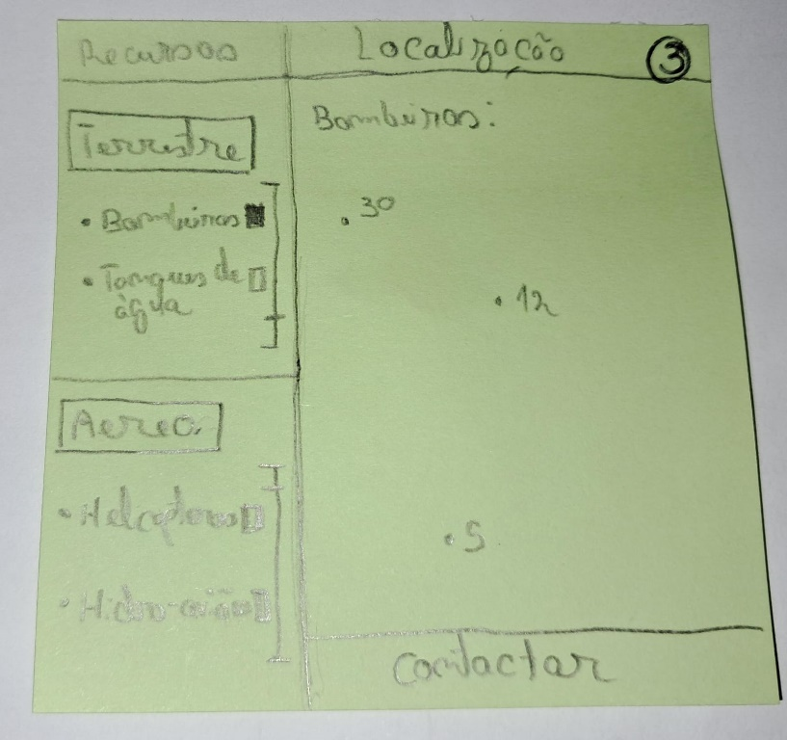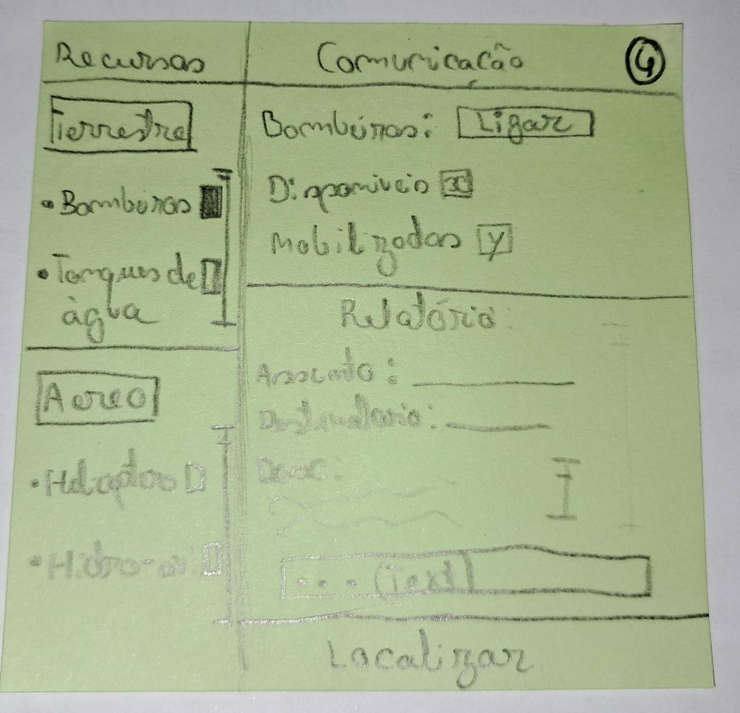

Figure 36 - Resources Panel Sketch 3 Figure 37 - Resources Panel Sketch 4

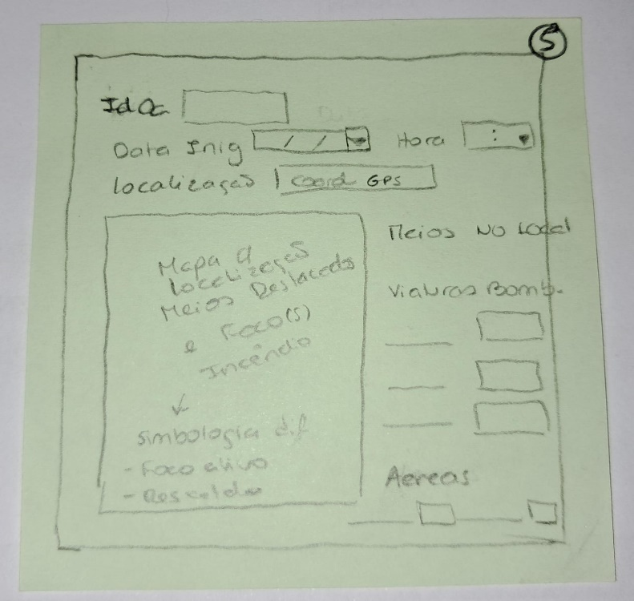

Figure 38 - Resources Panel Sketch 5

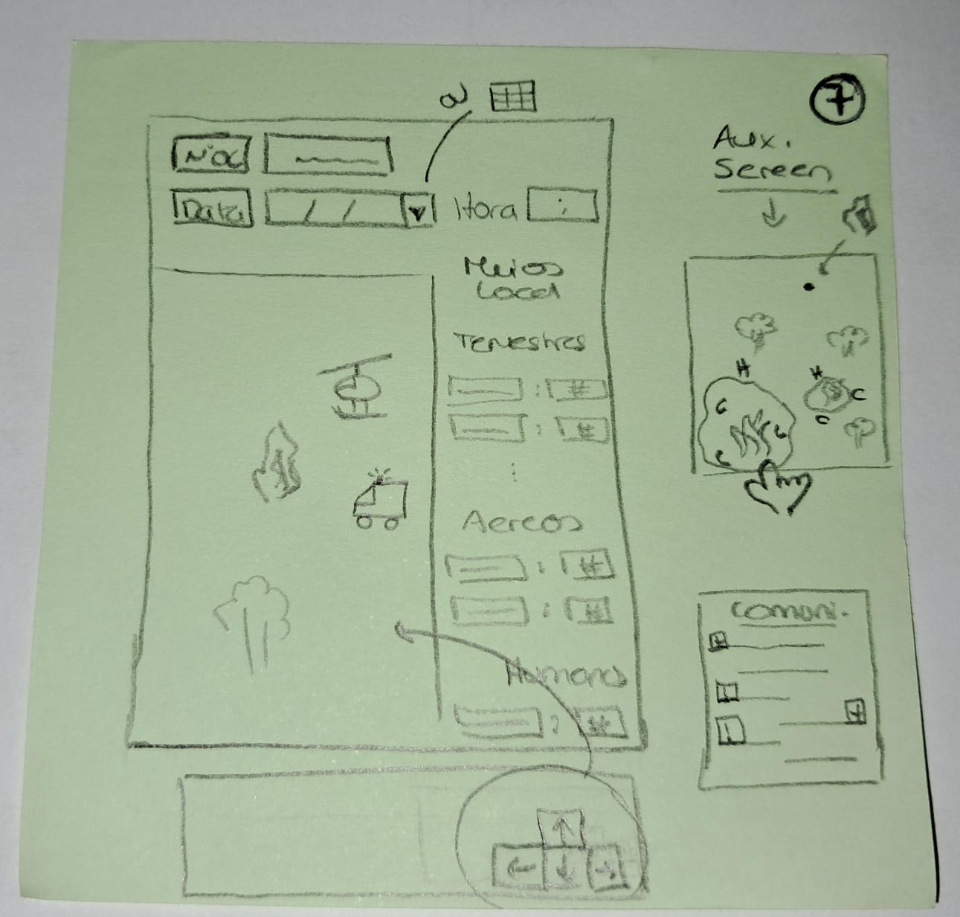 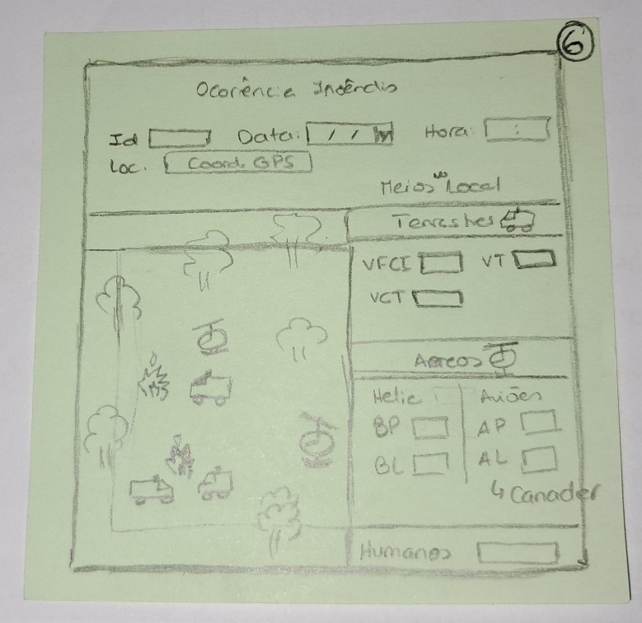

Figure 39 - Resources Panel Sketch 6 Figure 40 - Resources Panel Sketch 7

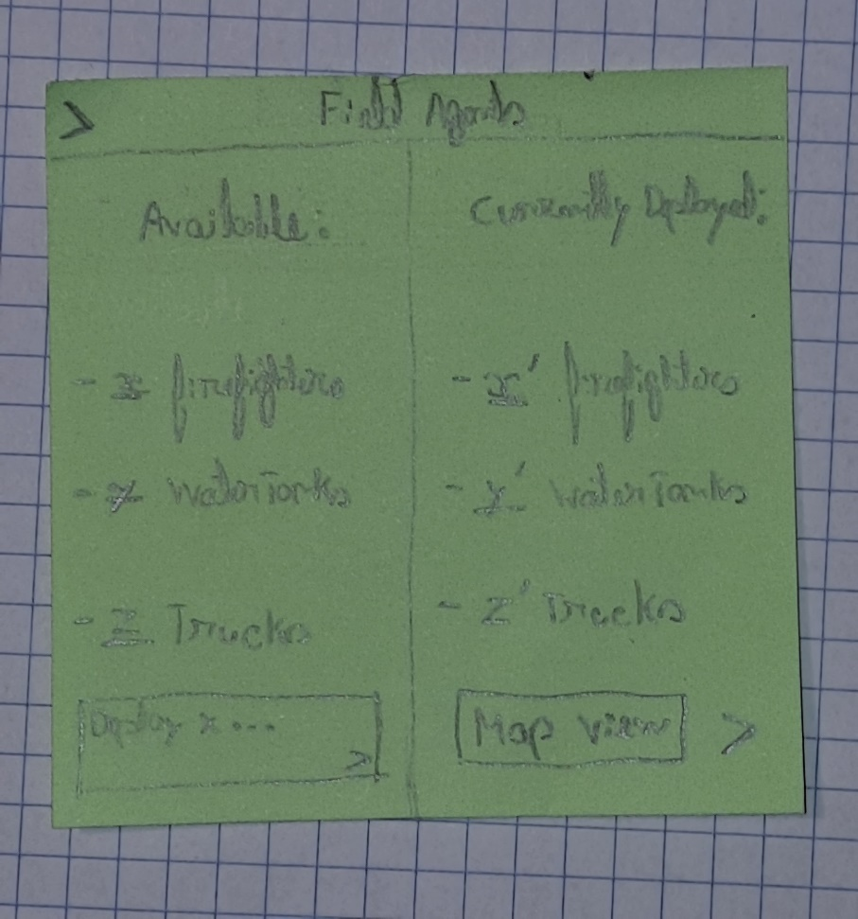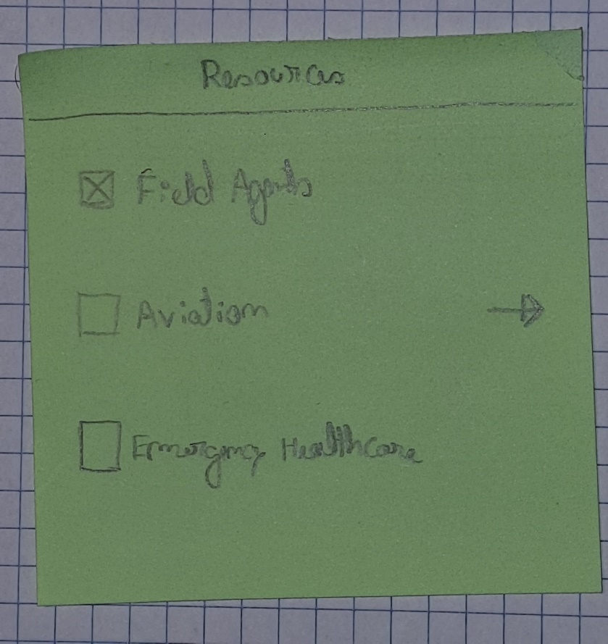

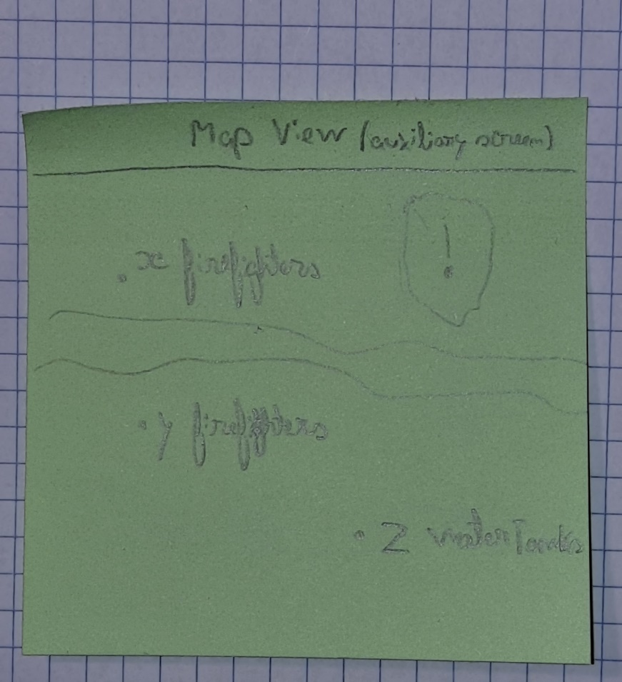

Figure 41 - Resources Panel Sketch 8 with auxiliary screen

## 2.2 Metrics Used for Evaluation

In order to evaluate the preliminary sketches that were produced, it was collectively determined that each sketch would be assessed according to four distinct criteria.

The criteria were defined as follows:

1. Functionality;
2. Intuitiveness or clarity;
3. Organization;
4. Attractiveness/Design;

Once all members of the group had evaluated the sketches, we proceeded to construct a matrix based on the above-mentioned four criteria. In this manner, a ranking was established, thereby facilitating discussion and progression in the process with regard to the most promising sketches.

## 2.3 Evaluation and Results

This section presents the evaluation grids for the initial sketches.

* **Situation Panel – Simple:**
  + Functionality:

Table 1 - Situation Panel evaluation of the functionality parameter

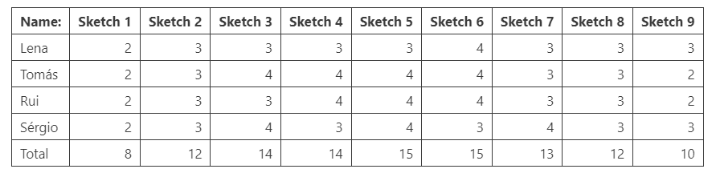

* + Intuitiveness:

Table 2 - Situation Panel evaluation of the intuitiveness parameter

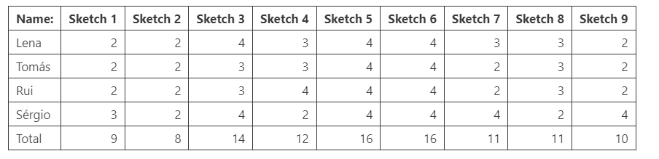

* + Organization:

Table 3 - Situation Panel evaluation of the organization parameter

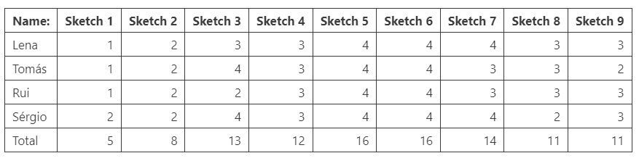

* + Attractiveness:

Table 4 - Situation Panel evaluation of the attractiveness parameter

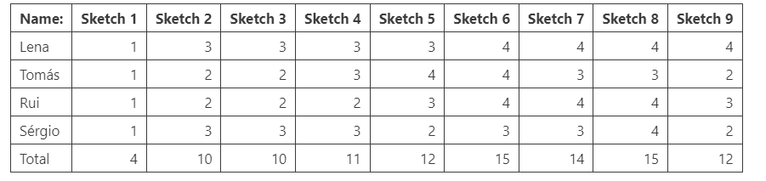

* + Final Score:

Table 5 - Situation Panel final scor

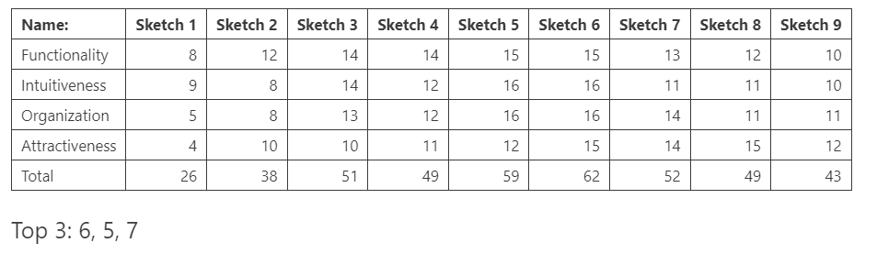

* **Situation Panel – Multiple:**
  + Functionality:

Table 6 - Multiple sensors evaluation of the functionality parameter

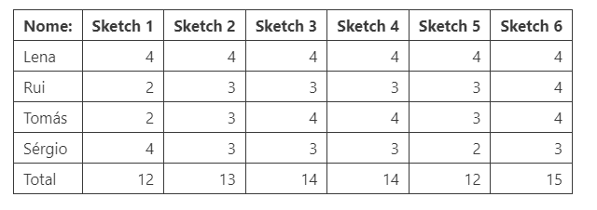

* + Intuitiveness:

Table 7 - Multiple Sensors evaluation of the intuitiveness parameter

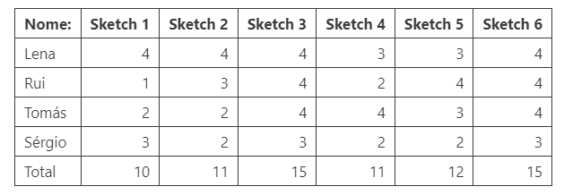

* + Organization:

Table 8 - Multiple Sensors organization of the parameter

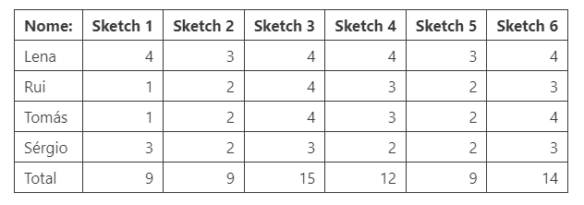

* + Attractiveness:

Table 9 - Multiple Sensors evaluation of the attractiveness parameter

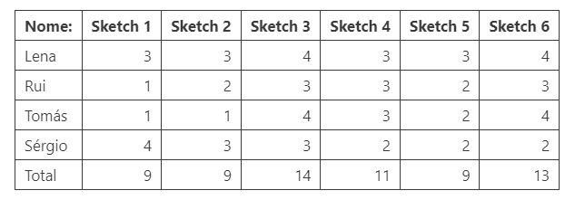

* + Final Score:

Table 10 - Multiple Sensors sinal score

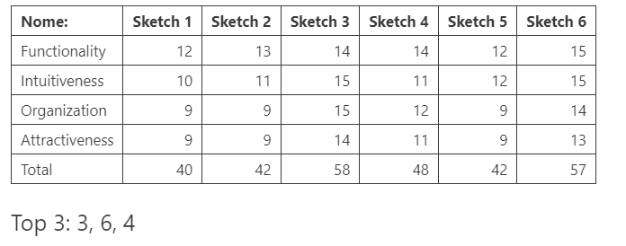

* **Camaras Panel:**
  + Functionality:

Table 11 - Camaras Panel evaluation of the functionality parameter

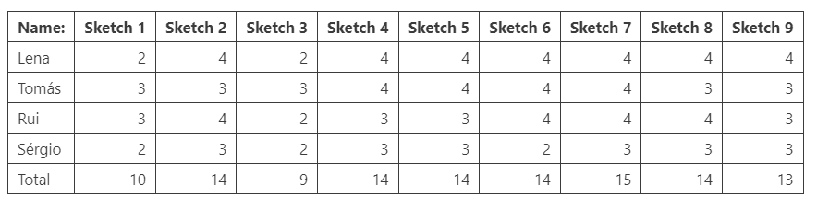

* + Intuitiveness:

Table 12 - Camaras Panel evaluation of the intuitiveness parameter

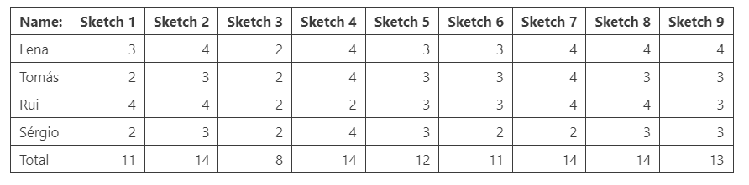

* + Organization:

Table 13 - Camaras Panel evaluation of the organization parameter

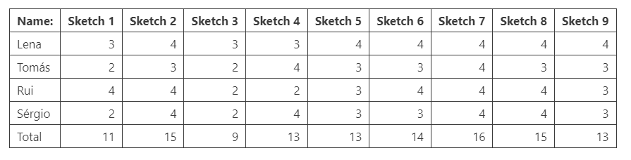

* + Attractiveness:

Table 14 - Camaras Panel evaluation of the attractiveness parameter

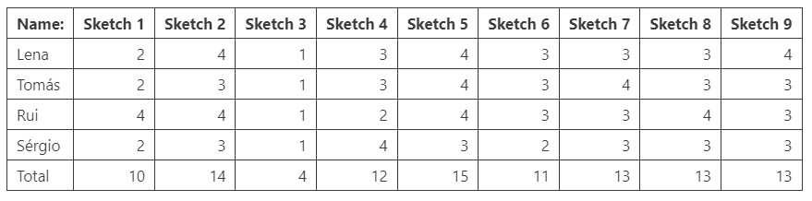

* + Final Score:

Table 15 - Camaras Panel final score

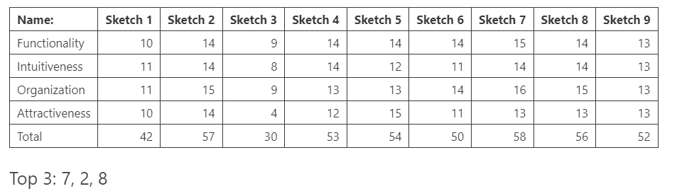

* **Log Panel:**
  + Functionality:

Table 16- Log Panel evaluation of the functionality parameter

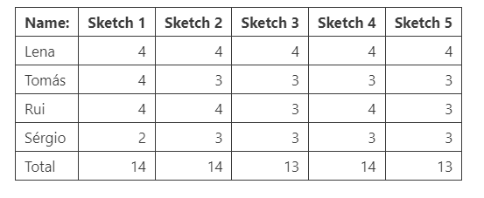

* + Intuitiveness:

Table 17- Log Panel evaluation of the intuitiveness parameter

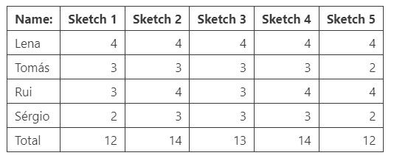

* + Organization:

Table 18- Log Panel evaluation of the organization parameter

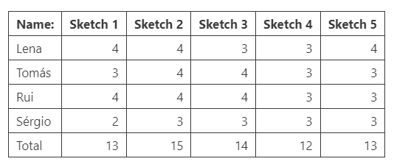

* + Attractiveness:

Table 19 - Log Panel evaluation of the attractiveness parameter

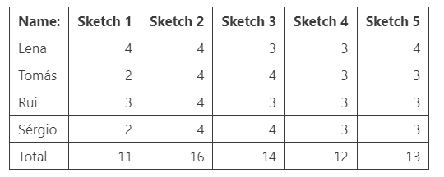

* + Final Score:

Table 20 - Log Panel final score

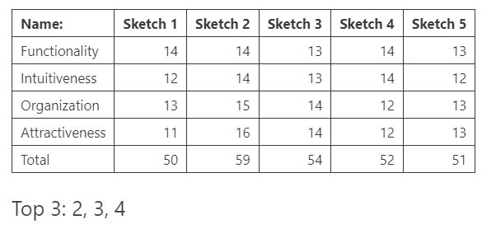

* **Resources Panel:**
  + Functionality:

Table 21- Resources Panel evaluation of the functionality parameter

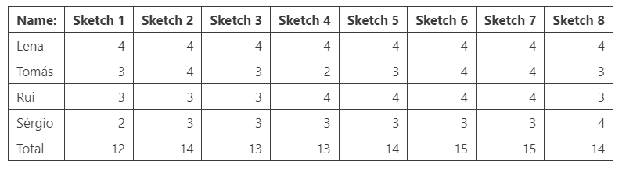

* + Intuitiveness:

Table 22 - Resources Panel evaluation of the intuitiveness parameter

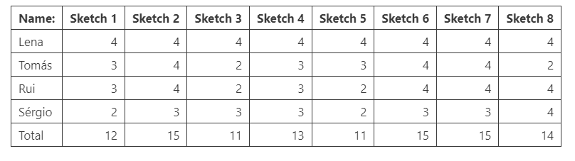

* + Organization:

Table 23 - Resources Panel evaluation of the organization parameter

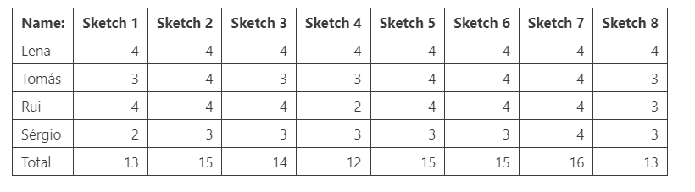

* + Attractiveness:

Table 24 - Resources Panel evaluation of the attractiveness parameter

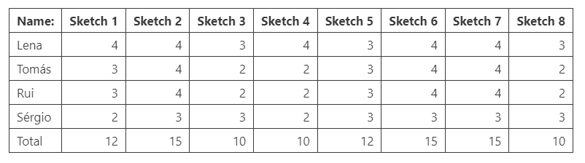

* + Final Score:

Table 25 - Resources Panel final score

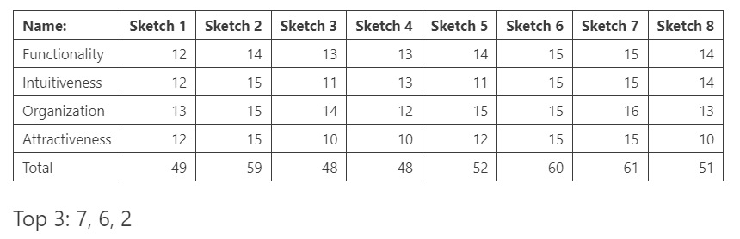

## 2.4 Iteration Process

To date, only one iteration has been conducted subsequent to the preliminary sketches. These sketches were developed on the foundation of the three most popular sketches from each panel.

It is our opinion that this process is not yet complete. It would be advantageous to engage in a discourse concerning the features and functionalities in question, subsequent to the evaluation, with a view to producing a new sketch for each of the panels.

Below are the most recent sketches.

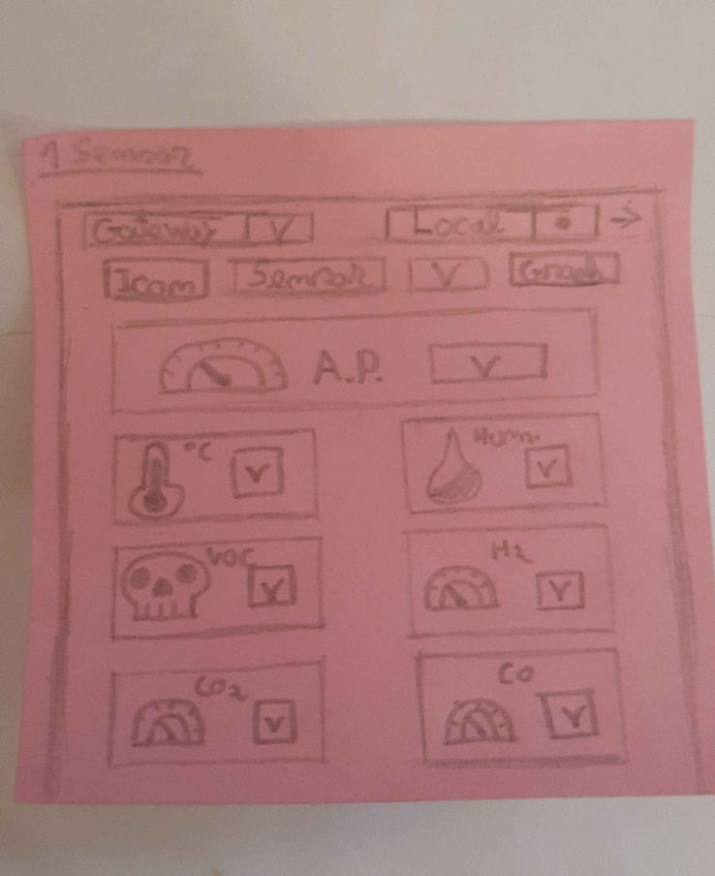 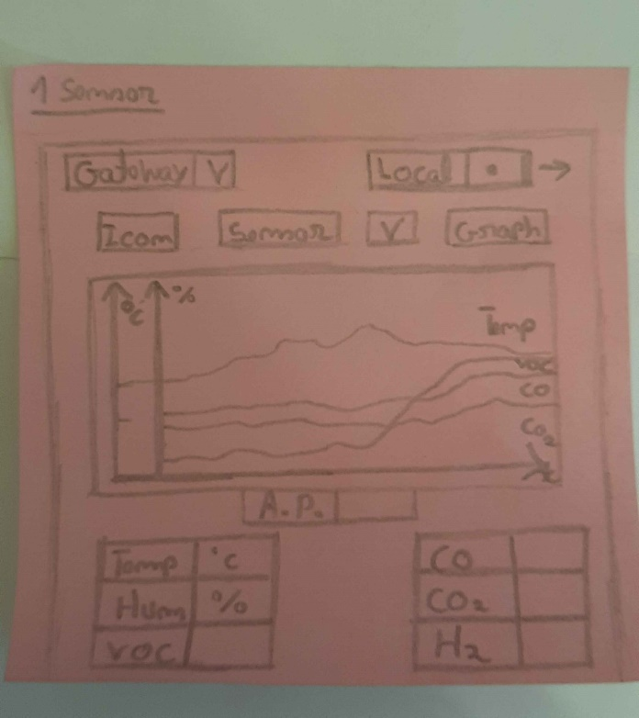

Figure 42 - Situation Panel Sketch 10 Figure 43 - Situation Panel Sketch 11

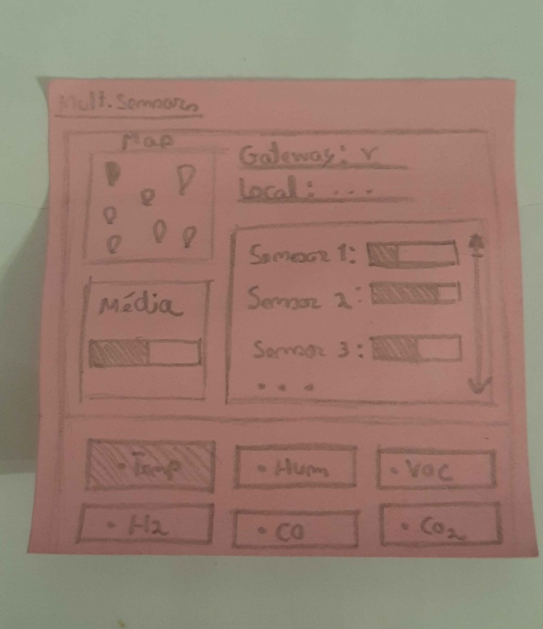 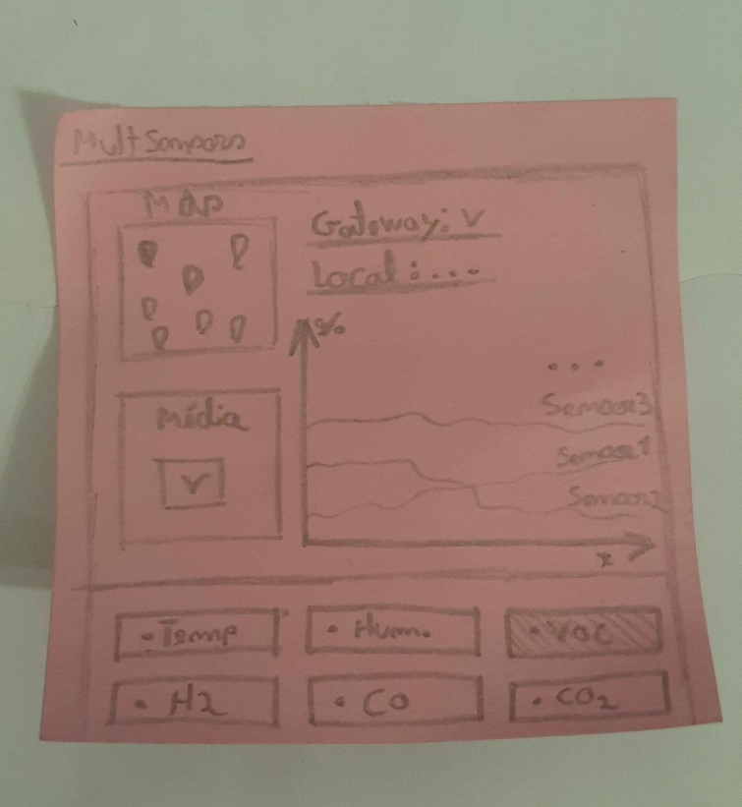

Figure 44 - Multiple sensors Sketch 7 Figure 45 - Multiple Sensors Sketch 8

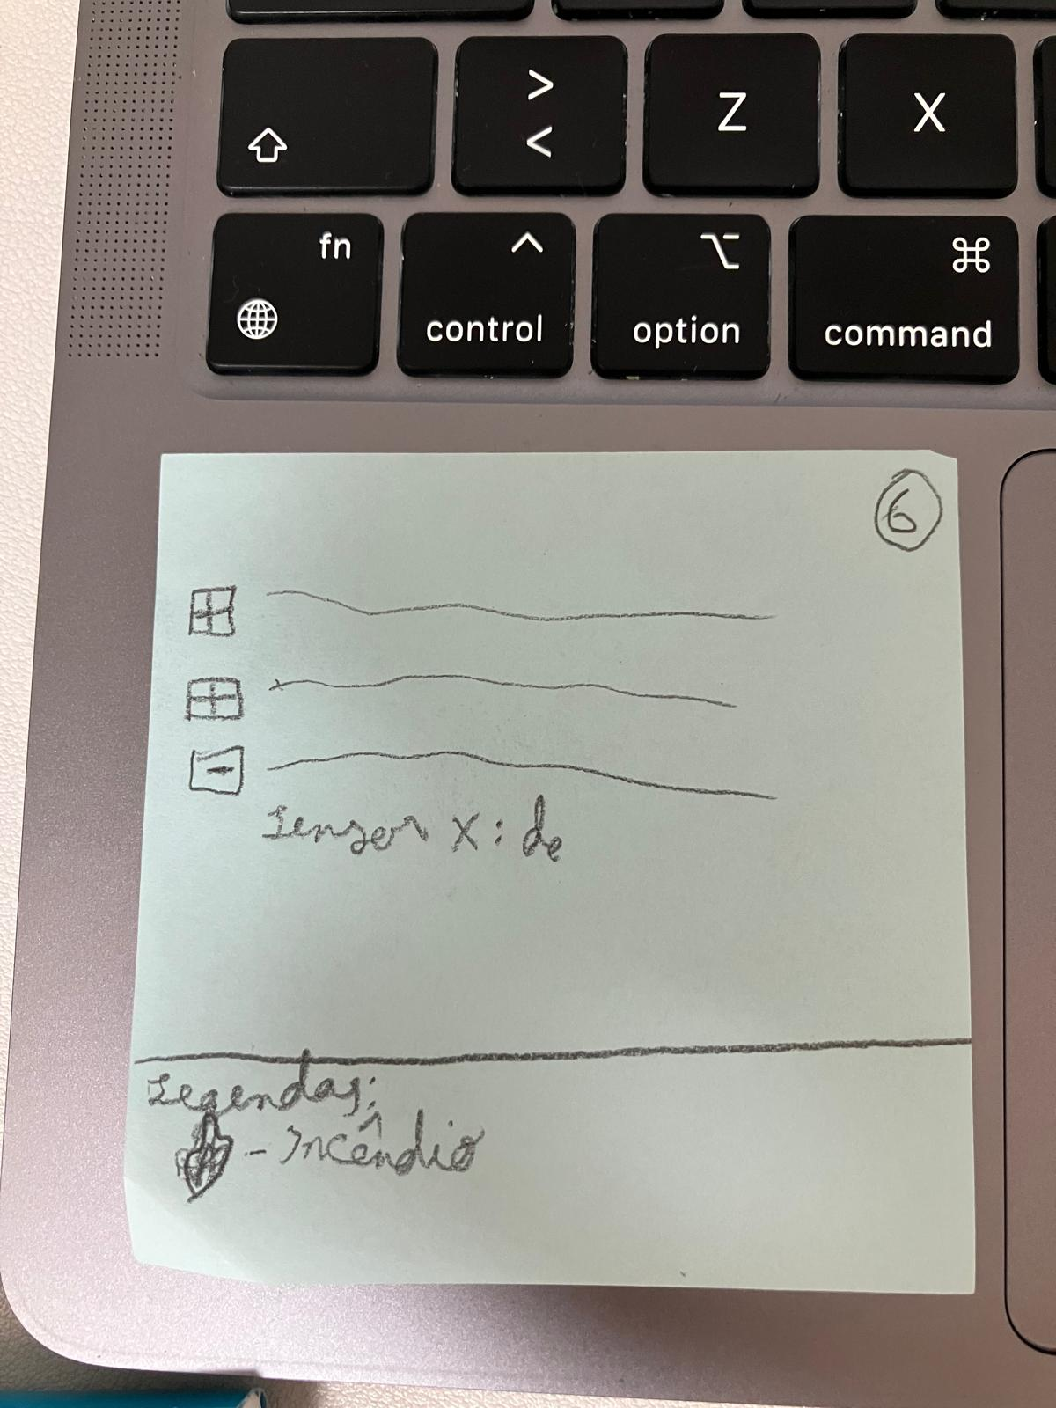 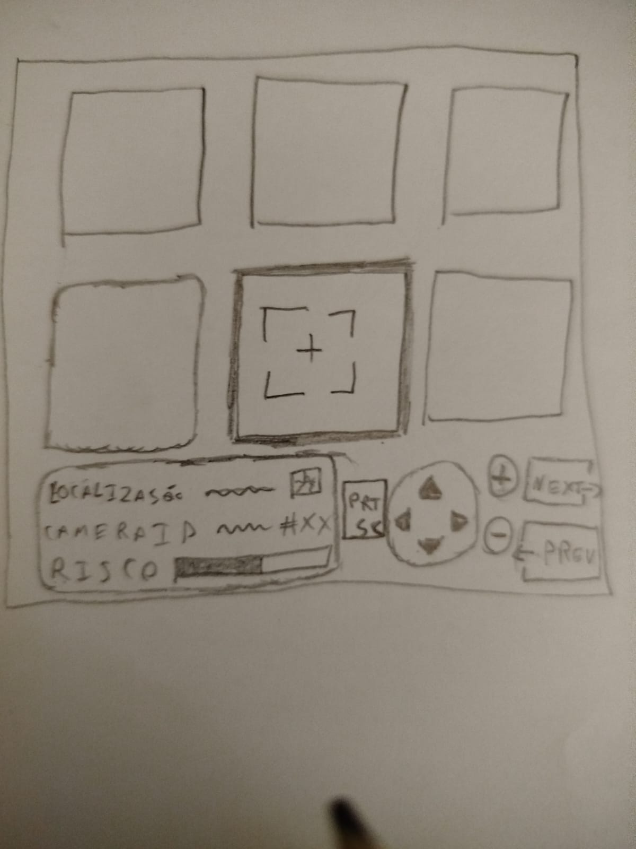

Figure 46 - Log Panel Sketch 6 Figure 47 - Camara Panel Sketch 10

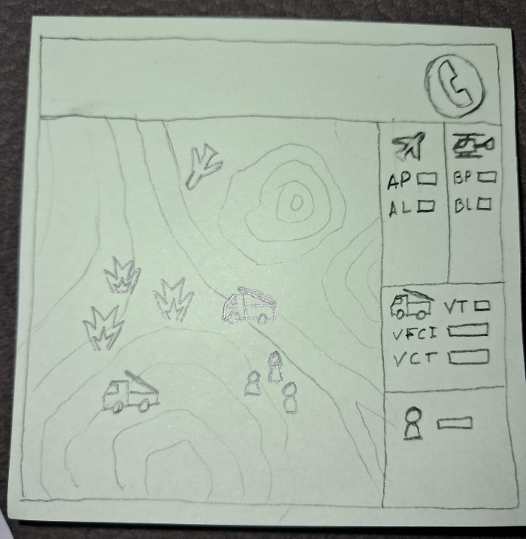

Figure 48 - Resources Panel Sketch 9

Upon completion of the final schematics for all the panels, a dashboard will be developed. The current layout of the dashboard is as follows:

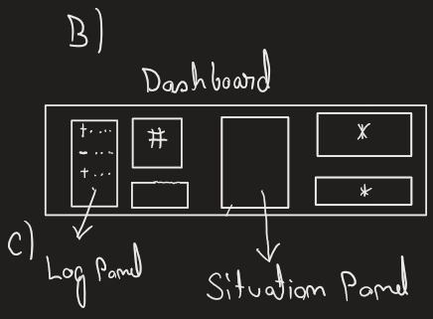 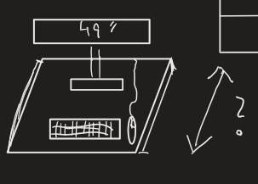

Figure 49 - The preliminary version of the dashboard at the stage of development

## 2.5 How to Interact with the Graphical Interfaces Created

For our Situation Panel we opted for two different approaches, based on the necessity of checking areas of the map through gateways or individual sensors.

Both ways allow the user to check for levels of air pressure, temperature, humidity, VOCs, H2, CO and CO2 detected by the sensors.

It can be done either through a simplified icon display for less details, or a graphical view to check the progress of the values through a time graph.

In the individual Sensor portion a user would typically choose a gateway and then a specific sensor to survey their current values.

For the Gateway portion it was an easy choice to include a portion of the screen to display the average of the values from all of the sensors in that gateway.

In addition, we also thought it would be more readable to display only the selected information at a time, since all of the sensors would be displayed at the same time, therefore the user would have to choose, at the bottom of the screen, which type of levels they want to check.

The concept of Log Panel is to provide a comprehensive and structured repository of all information pertaining to incidents, fire states, communications, and other pertinent data that may be relevant to the civil protection operator and shared with other stakeholders.

In this regard, the objective is to create topics containing keywords that can be expanded upon and to ensure that all pertinent information is visible, while unnecessary details are concealed.

The Camera Panel enables the user to monitor six cameras simultaneously, offering a range of functions for the management and analysis of the images captured. The user may select a camera by clicking directly on its window or by utilising the Next and Prev buttons to navigate between them. The directional controls facilitate the movement of the camera and the adjustment of the zoom, according to the user's requirements.

The panel displays information pertaining to the location, camera ID and risk level, as determined by the sensors, represented by a progress bar. The Prt Sc button enables the capture of an image of the selected camera, which may be employed for the purposes of recording and analysis.

A fundamental issue for the Resources Panel is the ability to visualise the map of the area where a fire is occurring, or even multiple occurrences in a given area of the district. We also want to be able to visualise not only the outbreaks on the map, but also the resources on the ground using GPS positions. We also want to have a range of relevant information available for managing the fire, such as the number and type of air and ground resources, as well as human resources on the ground.

Another fundamental aspect that we tried to optimise in this iteration was to highlight the communication button, which gives access to an auxiliary screen where we can elaborate further.

# **Conclusão**

Concluding our first report we want to emphasize the many lives and goods that can be saved and protected by the streamlining of detection and prevention systems like the one we tried to sketch. During the Portuguese wildfires of 2024 it surely would have been of great value to have had one such system in place to detect the fires that broke out during those nights. Furthermore, we would like to emphasize that an important task such as protecting society can’t indeed be trivialized and watered down so that it requires very little prior knowledge of the tools used. Much can still be improved to make the user experience even more accurate to the desired goal for our project, but we are proud of the ideas we collected and worked upon so that we will be able to make a prototype of our system.

# **Bibliographical References**

ICNF. (2024) Disponível em https://www.icnf.pt/ consultada a 8/novembro/2024

# **Appendices**

## A – Information about fire vehicles and procedures during wildfires

To better understand how a firefighter operates, who is the first line of defence, vehicles and people, we collected information from volunteer firefighters.

Firefighters utilise a range of forest firefighting vehicles, which are categorised according to their specific function and capacity. To illustrate, the VTTU are tank vehicles with a capacity of 12,000, 15,000 or 16,000 litres. These vehicles supply the smaller vehicles that combat fires, such as the VFCI (with a capacity of 3,000 litres) or VLCI. The VOPE is a reconnaissance vehicle that is used to observe and analyse the situation in order to establish or adjust the firefighting strategy. VECI vehicles are all-terrain vehicles and are the first to leave to fight the fire.

Upon reaching the ground, the firefighters establish communication with SIRESP, providing the coordinates of the location to the Operational Coordination Centre (OCC). The OCC is responsible for overseeing the entire situation and coordinating the deployment of additional resources or reallocation of existing ground, air, and human resources.

The information in question proved invaluable in the construction of the resource and log panels, as it enabled us to develop a comprehensive understanding of the subject matter.

Table 26 - Forest firefighting vehicles

|  |  |  |  |
| --- | --- | --- | --- |
| **Type** | **Description** | **Brand** | **Model** |
| VECI | VECI02 | Man(SEC) | T19F 19343 4x4 |
| VECI | VECI04 | Mercedes | BARIBI-1217-4X4 |
| VFCI | VFCI01 | Iveco | ML150E28WS |
| VLCI | VLCI05 | Mercedes (SEC) | UNIMOG U5000 |
| VLCI | VLCI07 | Mitsubishi (SEC) | L200 |
| VOPE | VOPE08 | Toyota | Hilux |
| VOPE | VOPE01 | Suzuki (Moto4) | LT-F250 |
| VTTU | VTTU04 | Volvo | FH12 |
| VTTU | VTTU06 | Volvo (SEC) | FL 10 4x2 |